# Text manipulation

## The bases

### Quotes use (\” vs ‘)

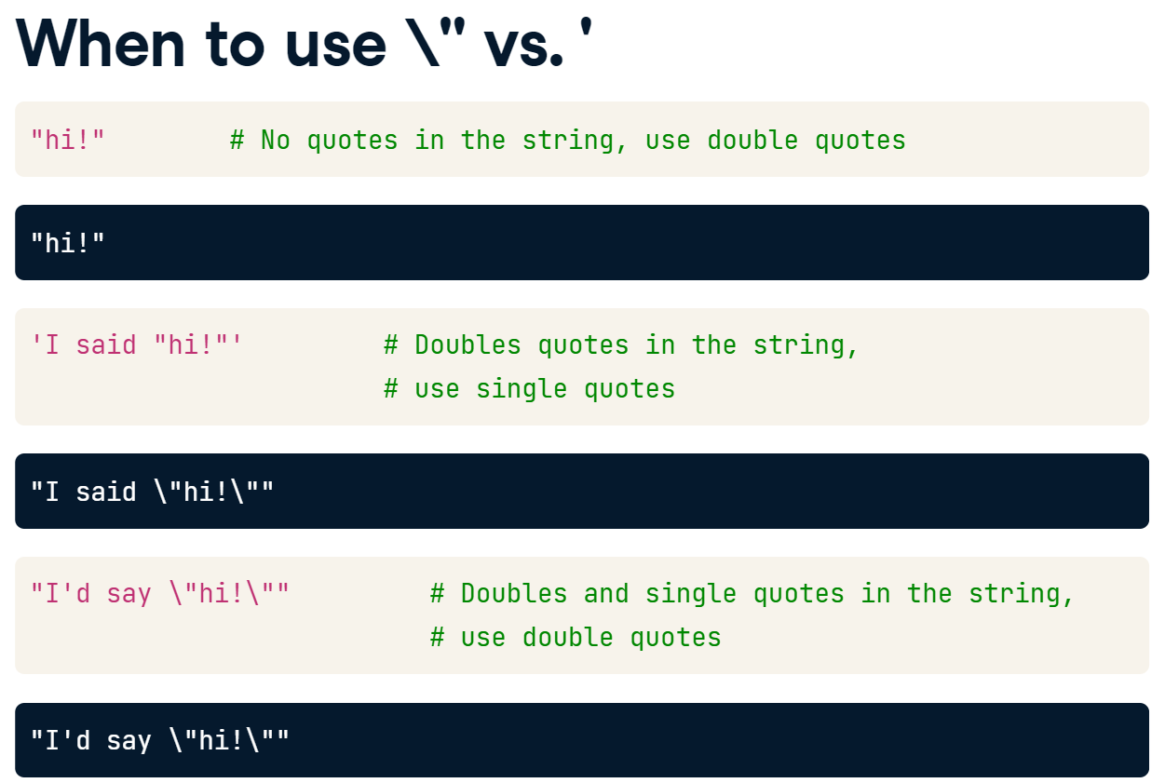

### Printing strings

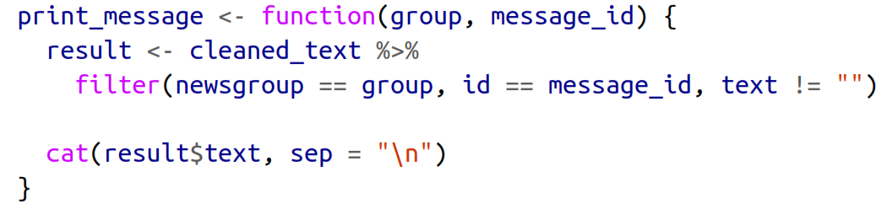

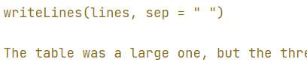

### Escape sequences

**\":** Denote a double quote.

**\n**: Gives a new line.

**\U:** Followed by up to 8 hex digits sequence denotes a particular Unicode character.

**\u:** Only need four digits for the codepoint. http://www.unicode.org/charts/

**\\:** To keep a backlash in the text.

### Unicode

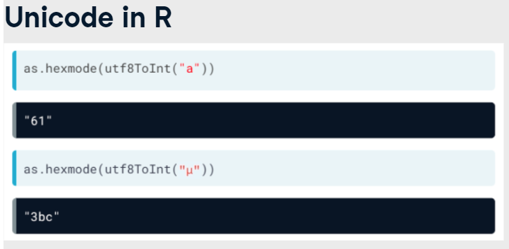

**stri_trans_nfc():** Composes characters with combining accents into *a single character*.

**stri_trans_nfd():** Decomposes character with accents into *separate letter and accent* characters.

In Unicode, an accent is known as a diacritic Unicode Property, and you can match it using the rebus value UP_DIACRITIC

## Functions with patterns in stringr

**stri_read_lines(): or readLines()**

**str_which(text, ___):**

**stri_isempty()**

**fixed(**“text”**):** Is useful if you are looking for patterns that contain punctuation like dots, dashes, brackets and slashes.

**str_detect() or %like% :** Answers the question “Does the string contain the pattern?”.

**str_sub():** Takes a subset of text by positions. It has the ability to use negative indexes to count from the end of a string.

str_sub(all_names, -2,-1): Last two letters.

str_sub(all_names, 1,1): First two letters

**str_subset() or grep():** We get a new vector of strings, but it only contains those original strings that contained the pattern.

**str_extract():** Returns a vector of the same length as that of the input vector.

**str_count() or nchar():** Answers the question "How many times does the pattern occur in each string?"

En el pattern podemos pasar un vector con diferentes patrones para tener multiples respuestas.

**str_split():**

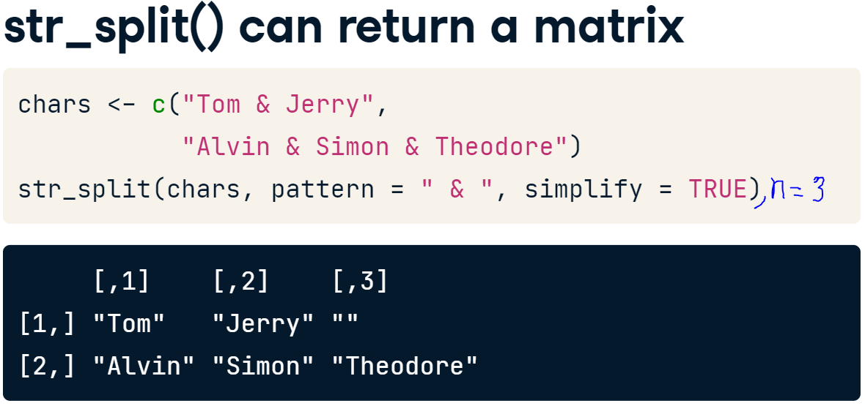

**str_length():** Says how long is a string.

**stringi::stri_trans_general(text,"Latin-ASCII"):** Retira todas las tildes de un texto.

**lapply(words, str_length):** count the number of characters in each word.

**str_replace():** replaces ***a*** pattern in the input strings with a specified replacement string.

**str_replace_all():** replaces ***all*** pattern in the input strings with a specified replacement string.

**str_remove():**

**str_view(match = TRUE):** It takes a string, and a pattern, and will open an HTML view with any matches to the pattern highlighted.

**regex(pattern, ignore_case = TRUE):**

**stri_trans_totitle():** Allows a specification of the type which, by default, is "word", resulting in title case, but can also be "sentence"

**str_extract():**

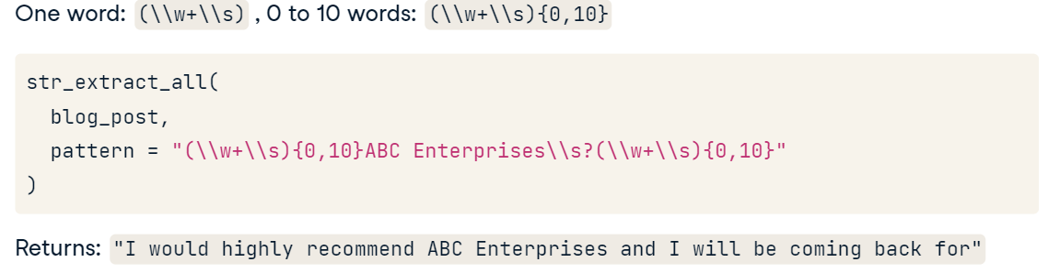

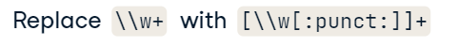

**str_match():**

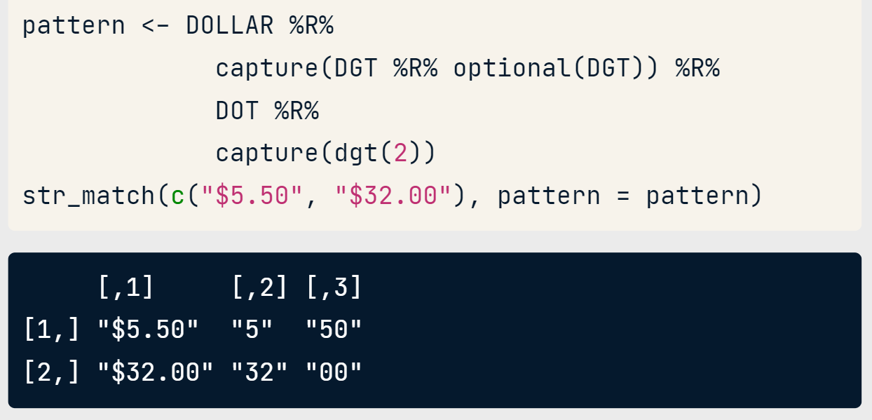

returns first the complete match and then the values for each capturing group.

str_match_all(): return a list and lapply can use this information.

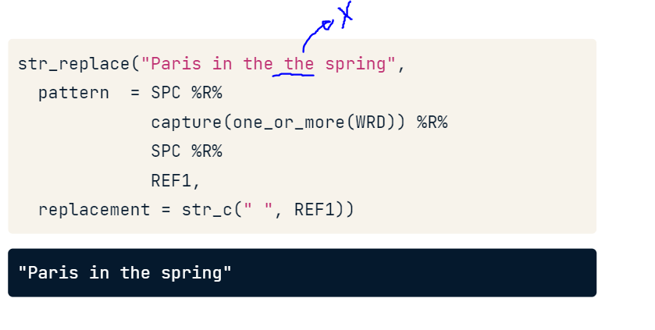

**tidyr::extract():**

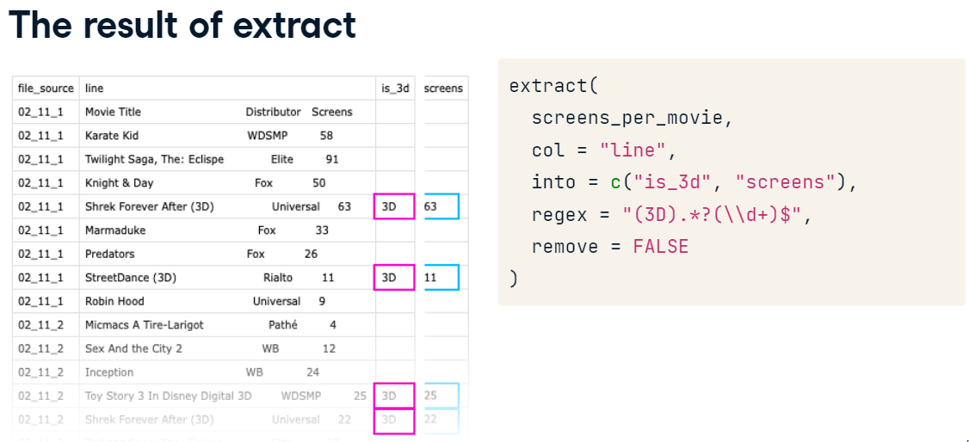

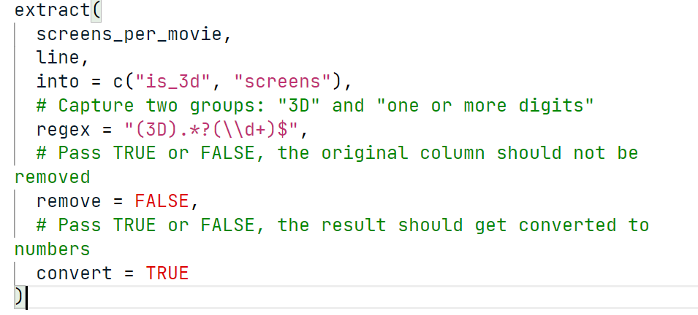

## Glue package

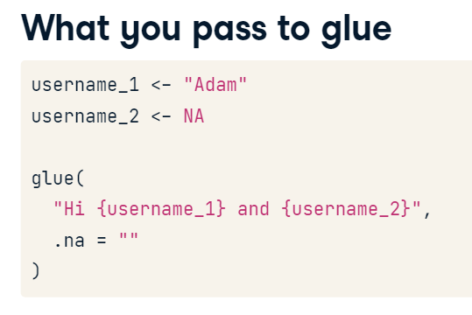

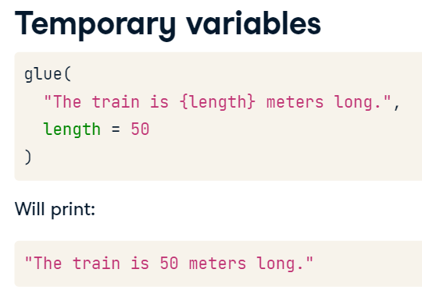

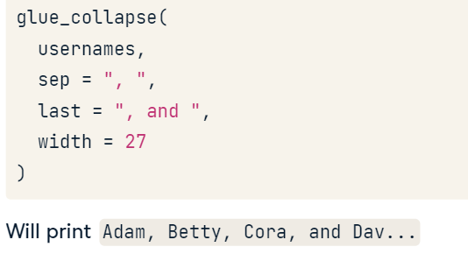

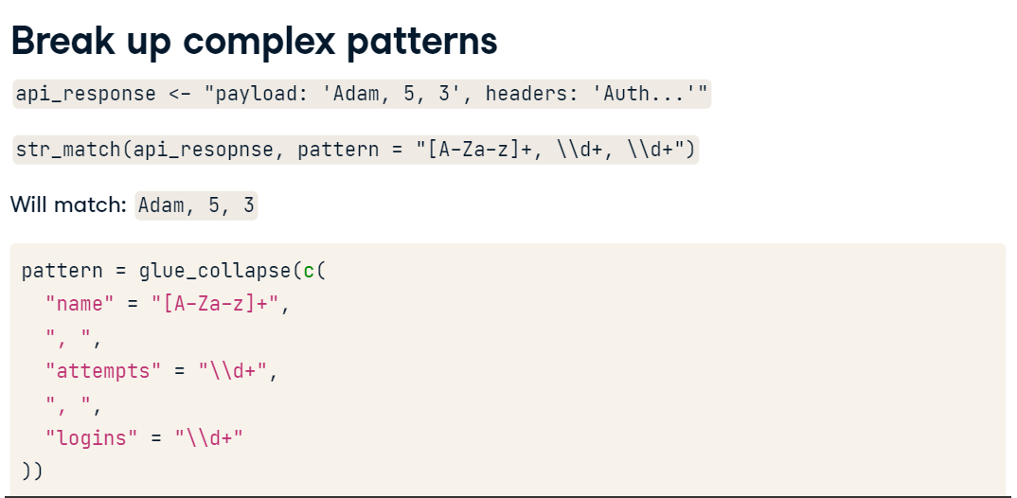

## Regular expressions

|  |  |  |
| --- | --- | --- |
| **Pattern** | **Regular Expression** | **rebus** |
| Then |  | %R% |
| Start of string | ^ | START |
| End of string | $ | END |
| Limita a que en el texto solo se vea el patrón | ^algo$ | exactly(“algo”) |
| One letter | . | ANY_CHAR |
| One lower letter |  | LOWER |
| Letters, numbers or underscores | \\w | WRD |
| A word | (\\w+\\s) |  |
| NOT Letters, numbers or underscores | \\W |  |
| Words | [A-Za-z] |  |
| Letras mayusculas |  | ascii_upper() |
| Digits | \\d | DGT |
| NOT digits | \\D |  |
| Accents |  | UP_DIACRITIC |
| Encuentra todas las letras tengan o no acento |  | GRAPHEME |
| Many white space, \t and \n | \\s | SPC |
| NOT Many white space, \t and \n | \\S |  |
| Literal dot, carat, dollar, Backreferences | \\., \\^, \\$, \\1-9 | DOT, CARAT, DOLLAR, REF1-9 |
| Todos los signos de puntación | [:punct:] |  |
| [A-Za-z] upper and lower case letters  [0-9] all numbers between 0-9  [Ss]hot (example- shot with caps or not) | [character_list] | char_class(pattern) |
| The first that don’t match | [^character_list] | Negated_char_class(pattern) |
| Used to identify groupings | () | capture() |
| Alternation | | | or(pattern1,pattern2) |
| one of the characters |  | or1(letters) |
| will only match if it occurs as a word on its own |  | whole_word("cat") |
| To extract numbers in a certain range |  | number_range() |
| To specify common date patterns |  | datetime() |
| **Repetition** | | |
| Match 0 - infinity times (Not sure) | * | zero_or_more() |
| Match 1 to infinity times (Sure) | + | one_or_more() |
| Match 0-1 times (Optional) | ? | optional() |
| Makes lazy our patterns from a greedy form | ? |  |
| Between m and n times | {m,n} | repeated() |
| Une or two digits  Two or more digits | \\d{1,2}  \\d{2,} | dgt(1, 2) |

# Use this pattern

three_digits <- DGT %R% DGT %R% DGT

four_digits <- three_digits %R% DGT

separator <- char_class("-.() ")

phone_pattern <- optional(OPEN_PAREN) %R%

  three_digits %R%

  zero_or_more(separator) %R%

  three_digits %R%

  zero_or_more(separator) %R%

  four_digits

one_or_more("\\d") %R% zero_or_more(" ") %R% or("YO","YR","MO")

If you want a challenge, get the neiss package and see if you can extract age and gender from all accidents.

## stringdist package

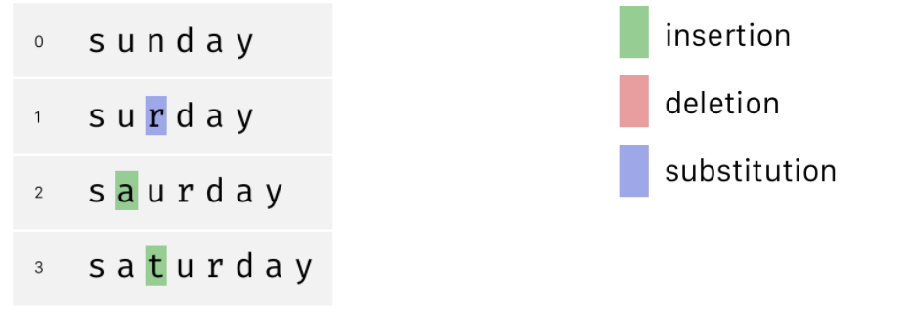

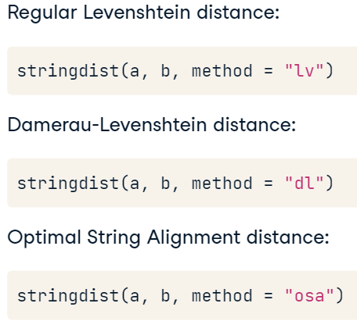

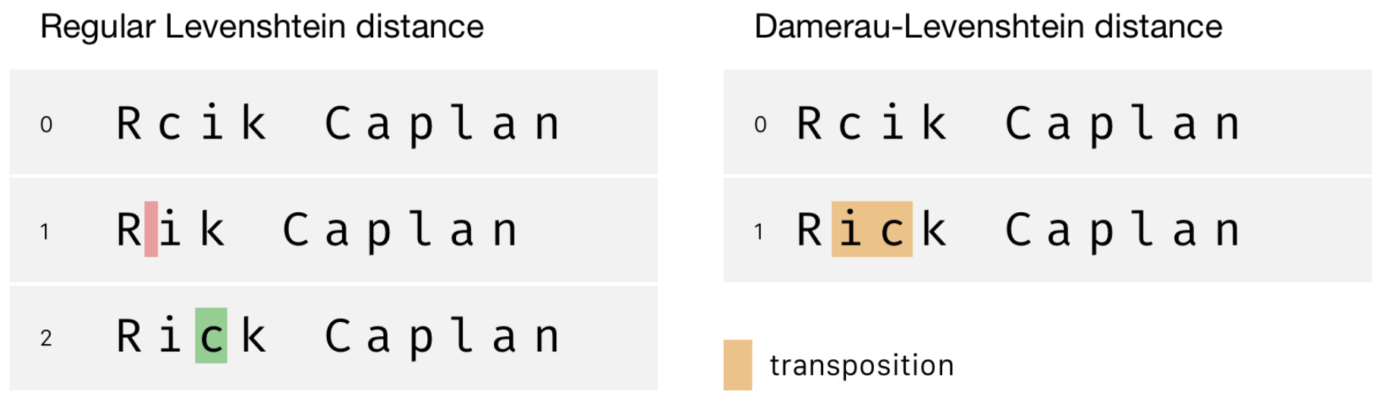

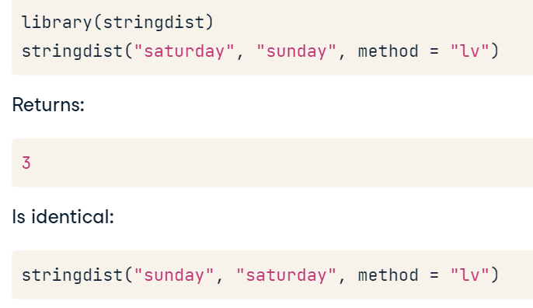

**amatch():** Tells us if a search input "x" can be found in a vector "table" (vector).

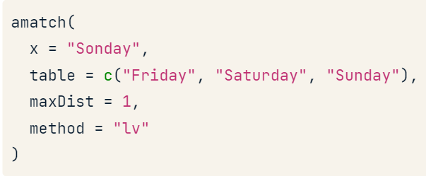

"Qgrams" are overlapping substrings of a certain length, but this sounds more complicated than it is.

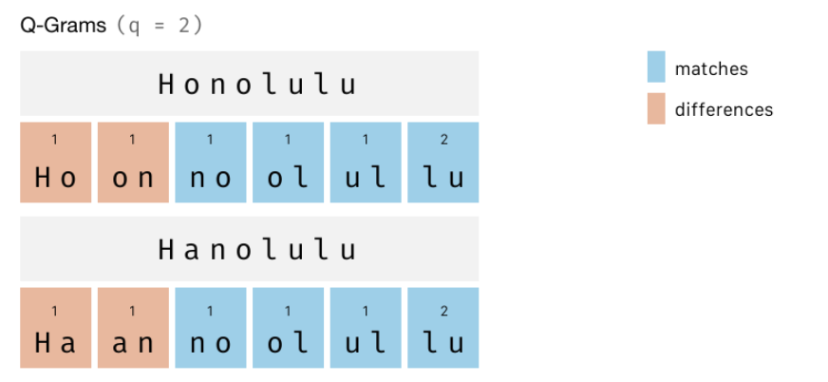

It is just **the sum of all qgrams that are not shared**, so in our case: 4. These are the orange ones.

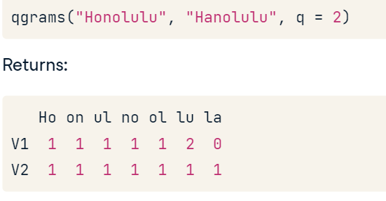

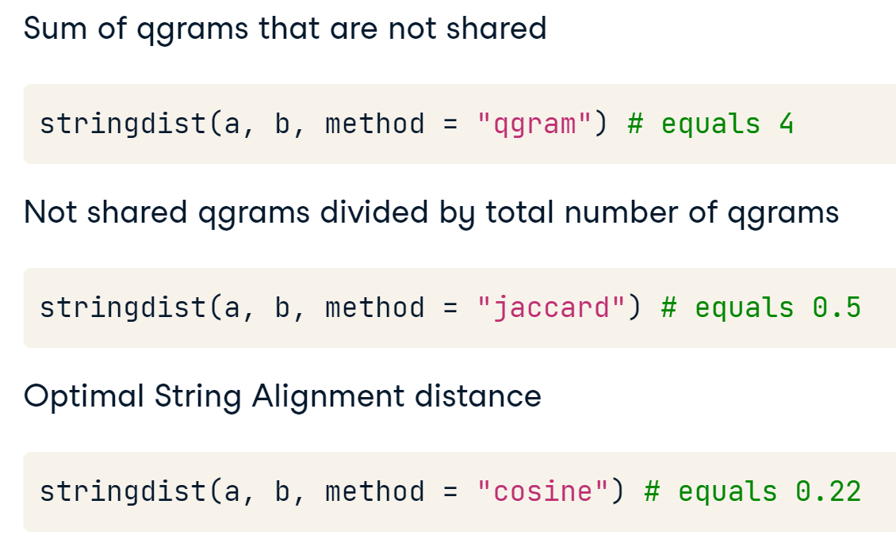

## fuzzyjoin package

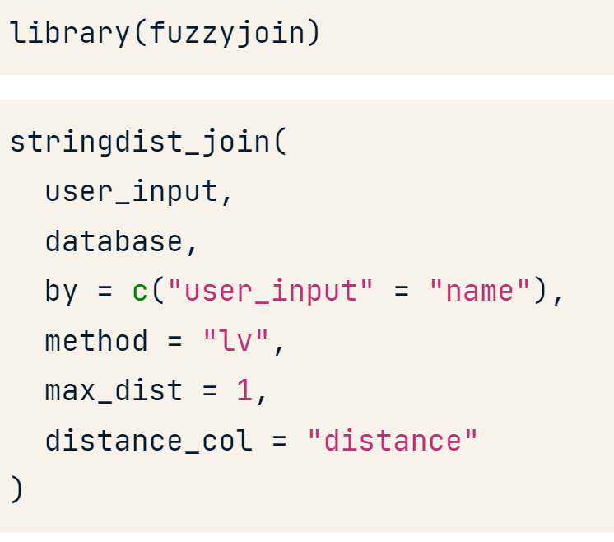

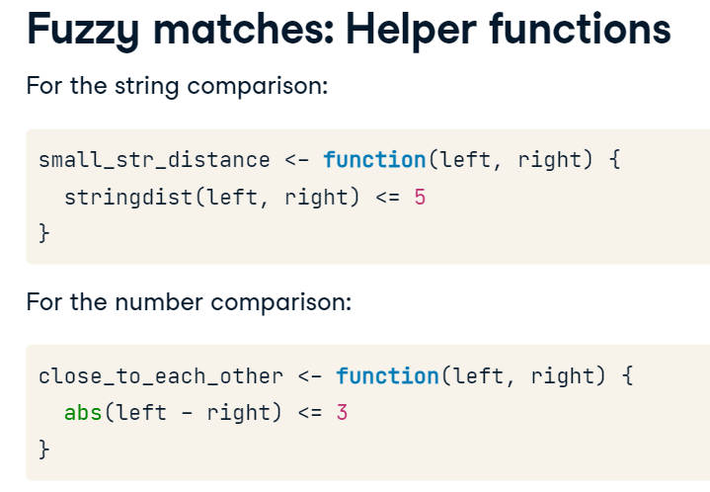

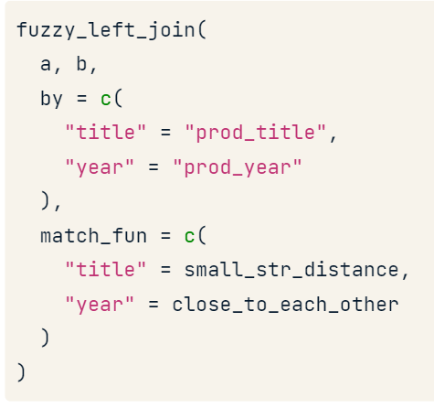

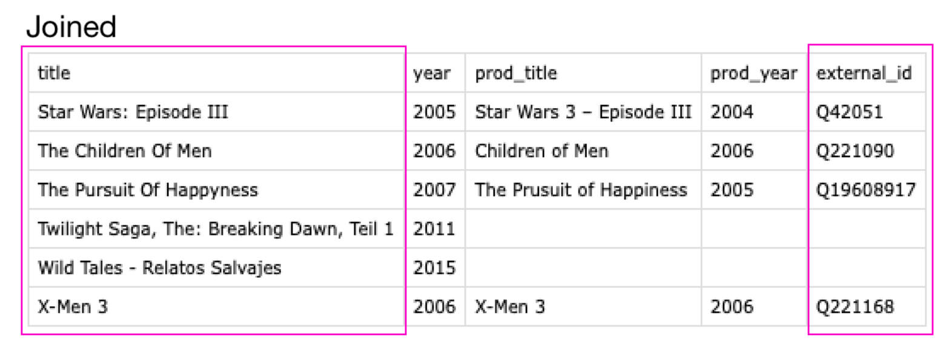

# Text mining

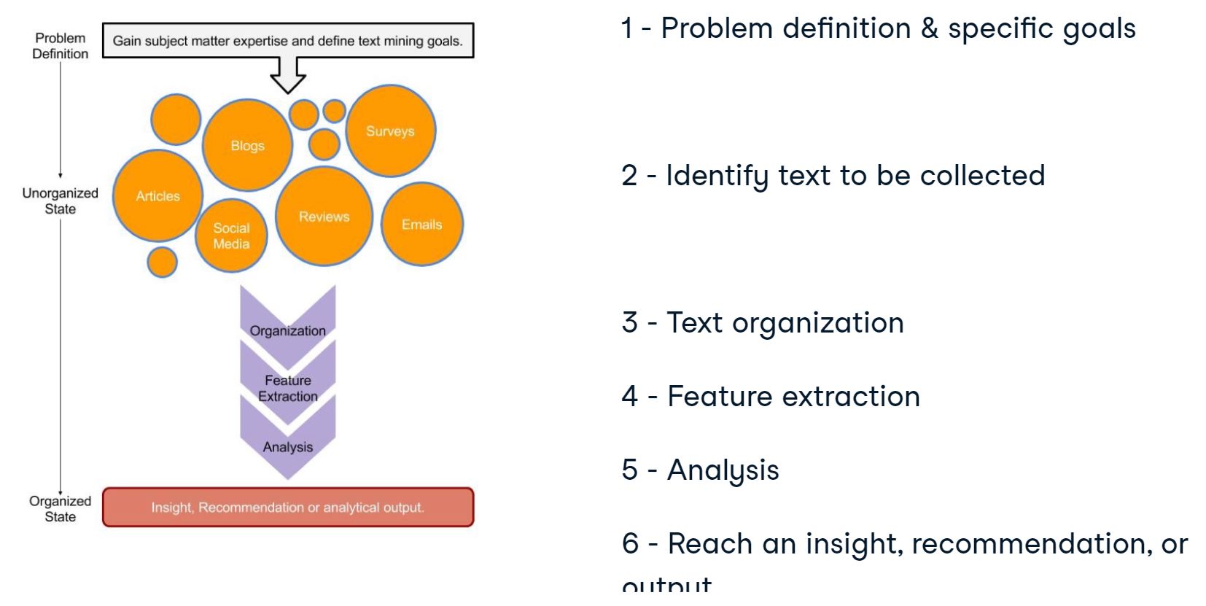

## Cleaning text

### qdap

The **qdap** package offers other text cleaning functions. Each is useful in its own way and is particularly powerful when combined with the others.

**bracketX():** Remove all text within brackets (e.g. "It's (so) cool" becomes "It's cool")

**replace_number()**: Replace numbers with their word equivalents (e.g. "2" becomes "two")

**replace_abbreviation()**: Replace abbreviations with their full text equivalents (e.g. "Sr" becomes "Senior")

**replace_contraction()**: Convert contractions back to their base words (e.g. "shouldn't" becomes "should not")

**replace_symbol()** Replace common symbols with their word equivalents (e.g. "$" becomes "dollar")

### tm

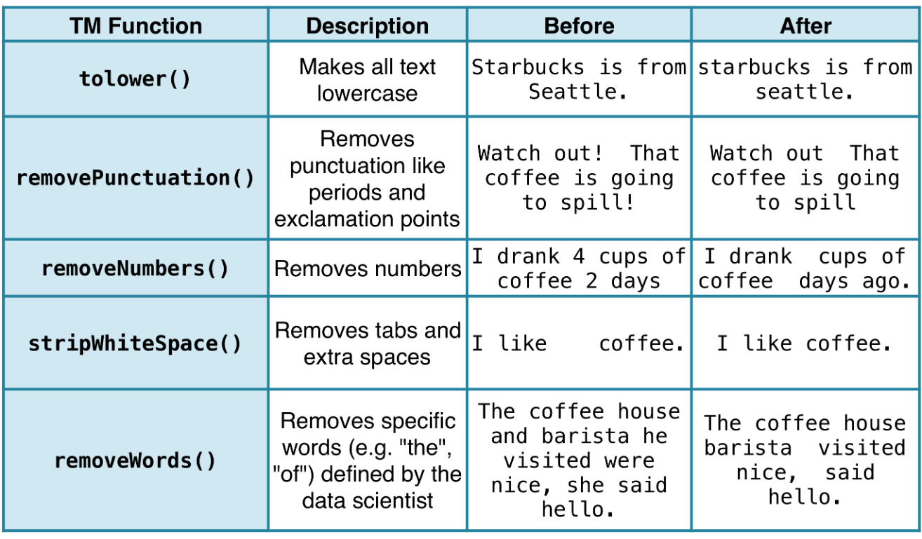

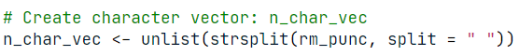

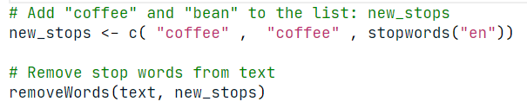

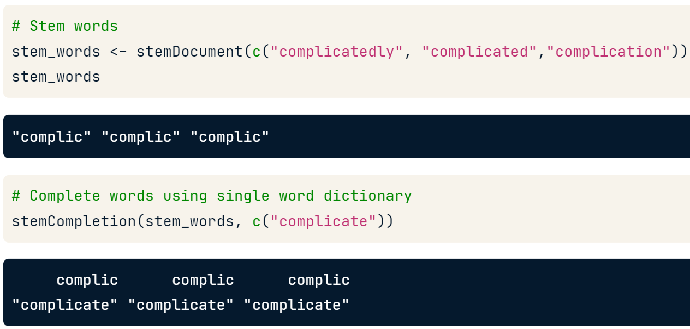

## Tokenizing text

### tidytext

* One world per row

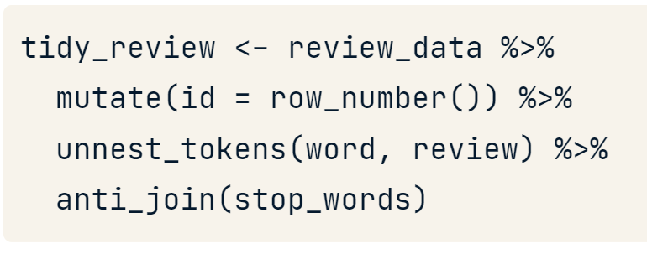

* Two worlds per row: a typical two-word pair is rarer than either of its component words. This technique works well for proper names.

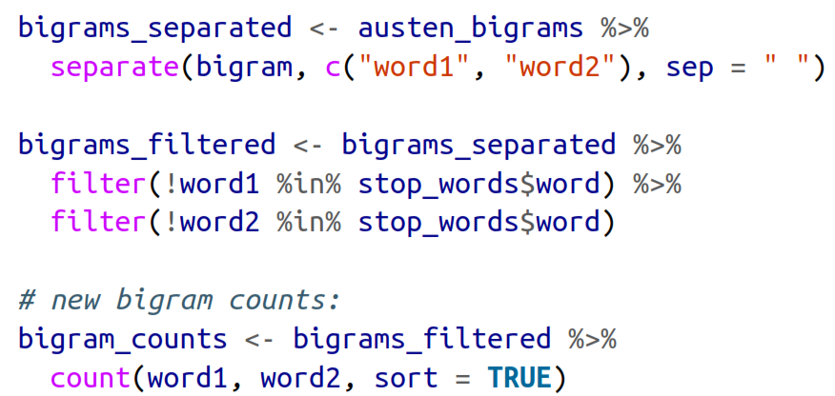

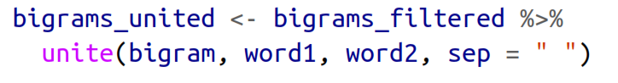

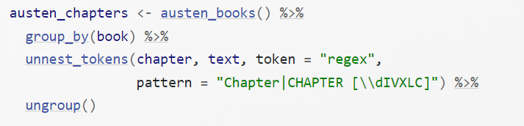

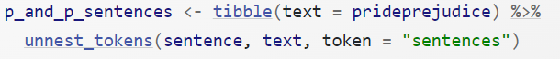

### tm

#### One word token

**FROM a vector**

coffee_source <- VectorSource(coffee_tweets)

coffee_corpus <- VCorpus(coffee_source)

**FROM a data.frame**

If your text data is in a data frame, you can use DataframeSource() for your analysis. The data frame passed to **DataframeSource()** must have a specific structure:

* Column one must be called **doc_id** and contain a unique string for each row.
* Column two must be called **text** with "UTF-8" encoding (pretty standard).
* Any other columns, **3+,** are considered metadata and will be retained as such.

df_source <- DataframeSource(example_text)

df_corpus <- VCorpus(df_source)

# Print the contents of the 15th tweet in coffee_corpus

coffee_corpus[[15]][1]

content(coffee_corpus[[15]])

meta(df_corpus)

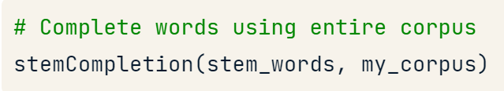

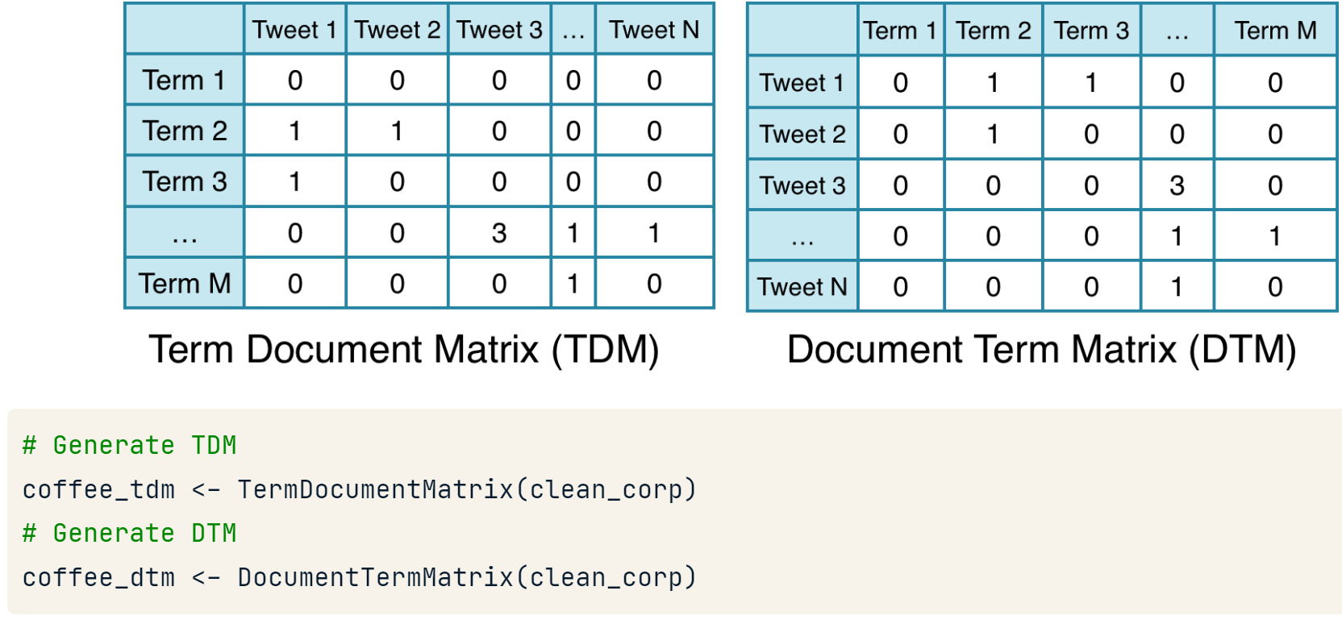

**Let’s keep metadata**

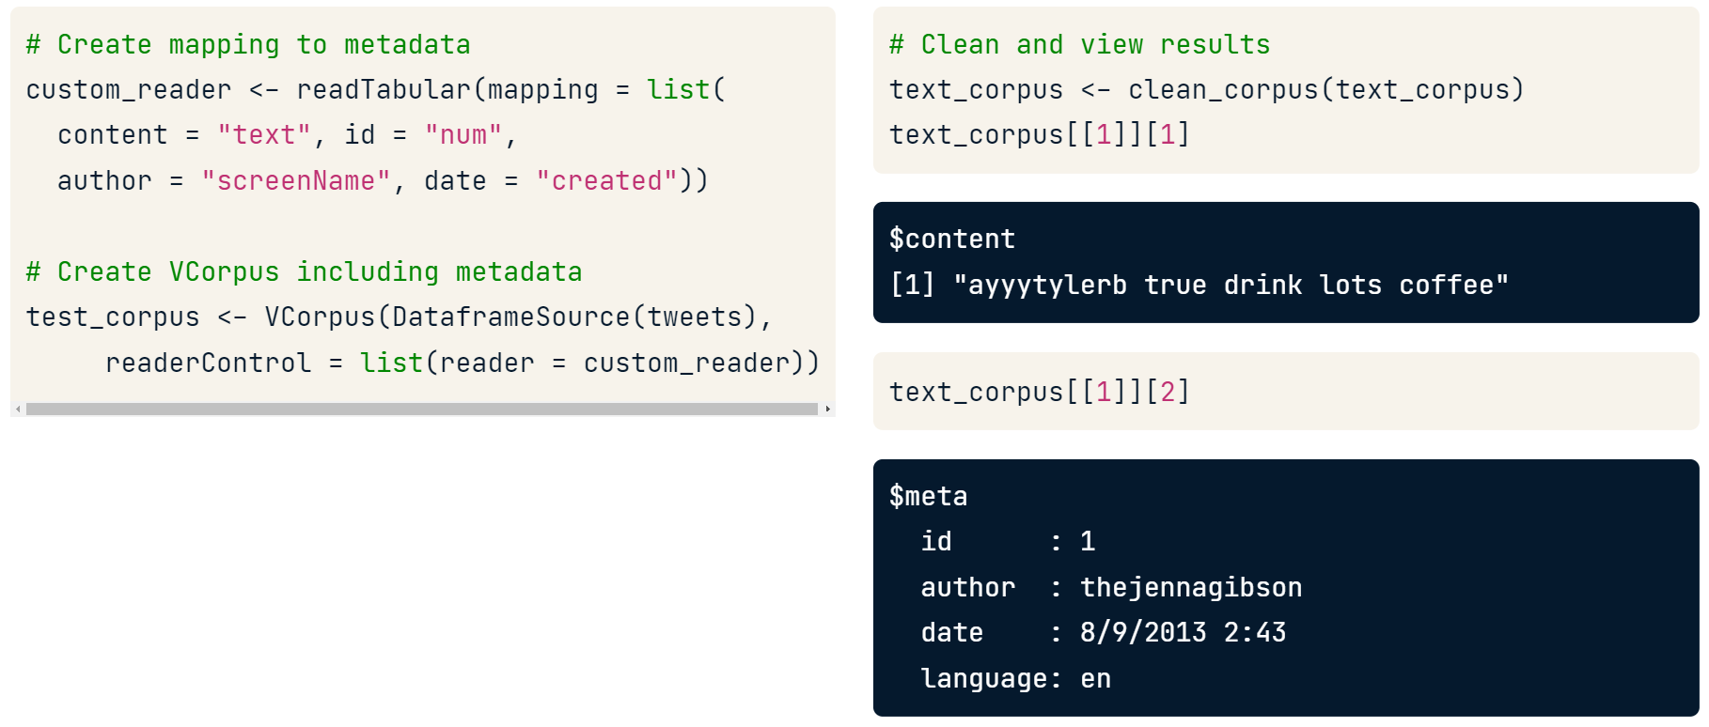

With a class "simple triplet matrix" but we can apply as.matrix()

#### n gram tokes

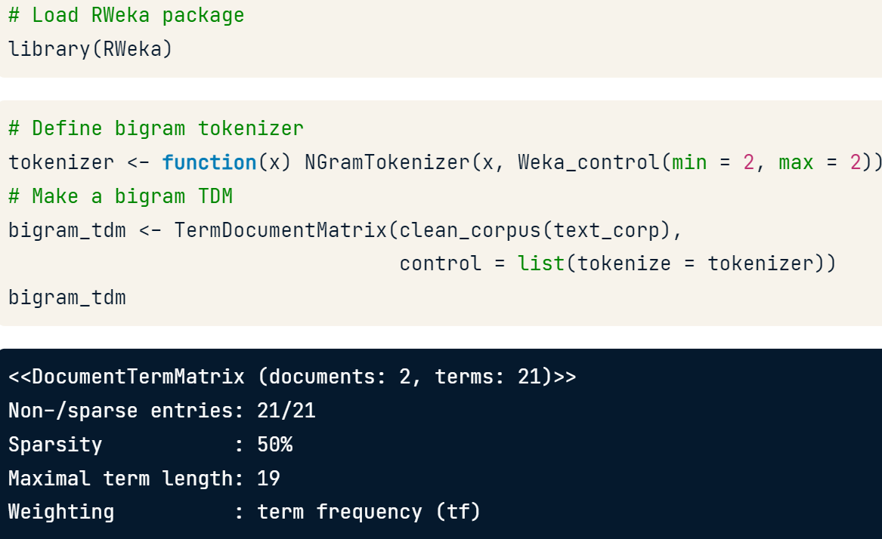

#### Cleaning a corpus

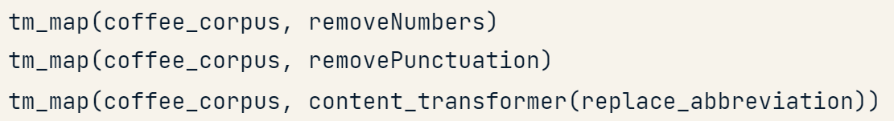

### qdap

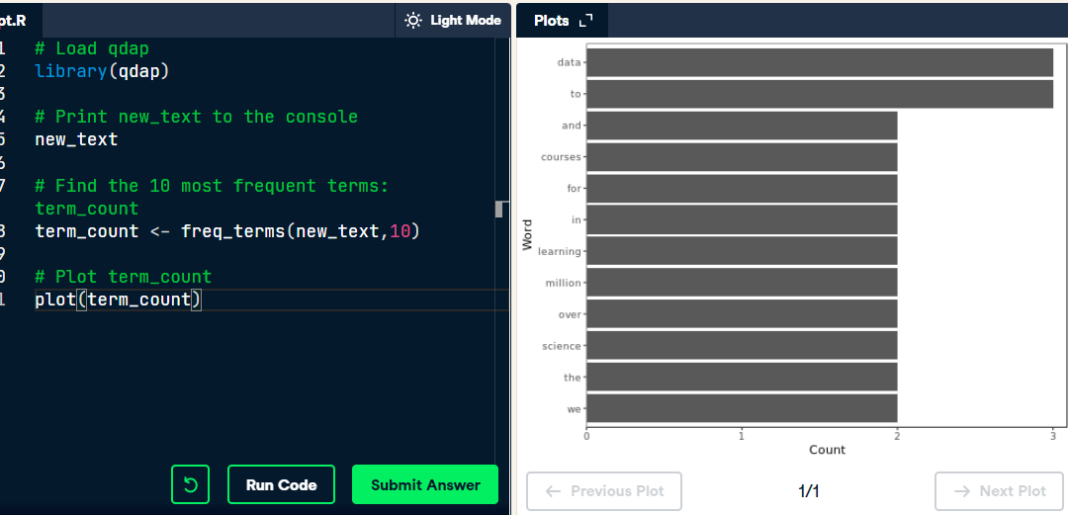

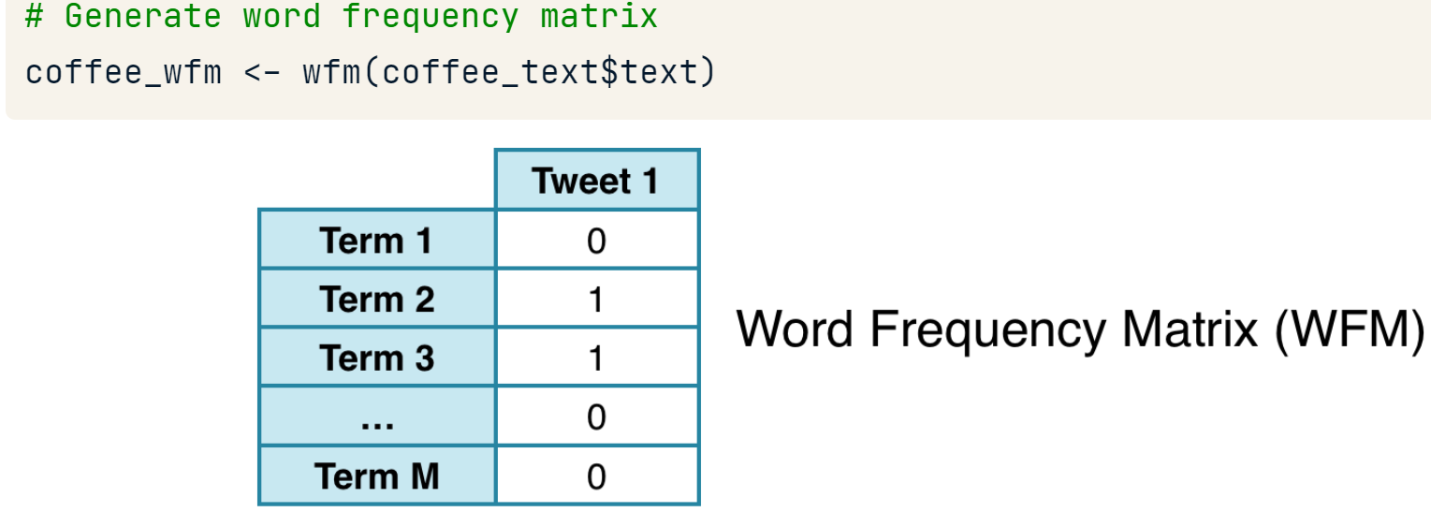

## Notidy converstions

### From and to DocumentTermMatrix (tm, topicmodels)

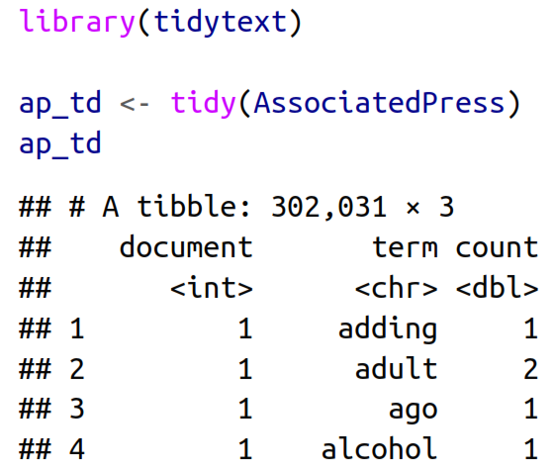

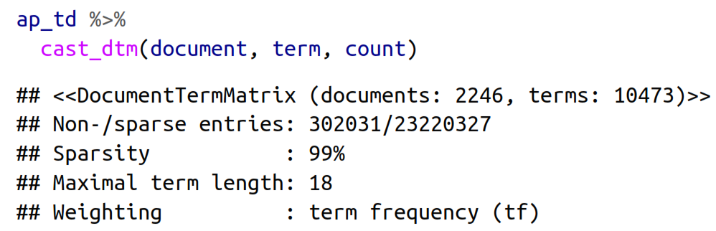

### From and to dfm (quanteda)

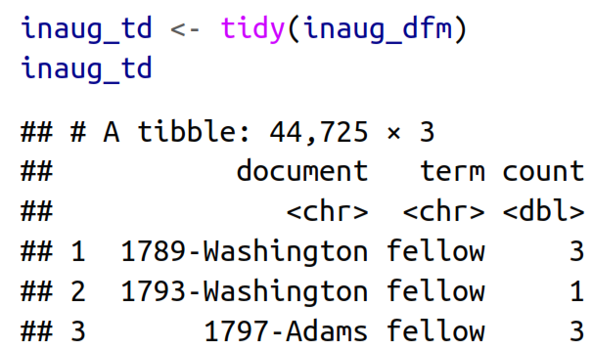

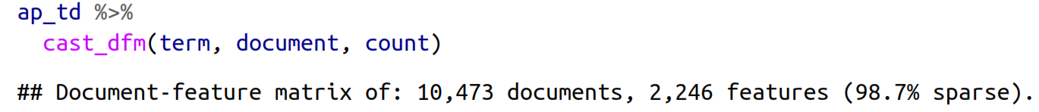

## Useful text metrics

### Word count

Which key-word pairs occur most often

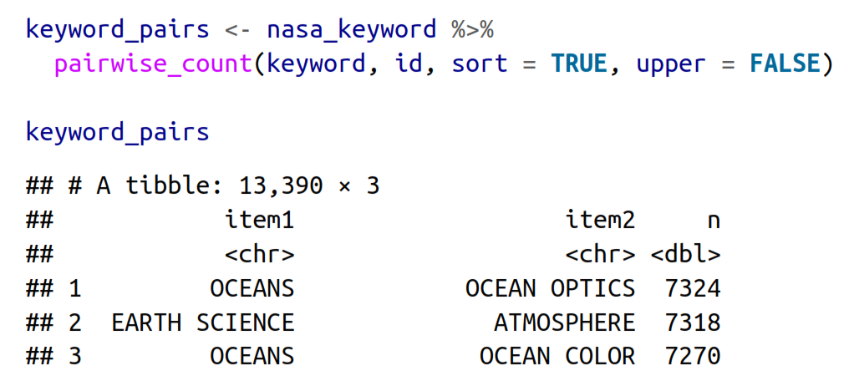

### Proportion of words per group

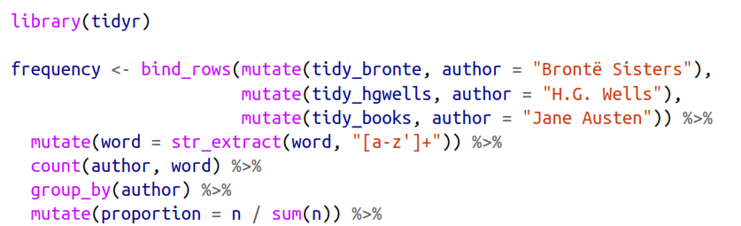

### Correlation test between groups

The **phi coefficient** indicates which keywords occur more often together than with other keywords or how often words appear together relative to how often they appear separately.

***If r = 1, the words are redundant we can delete one***

* Getting a general measurement

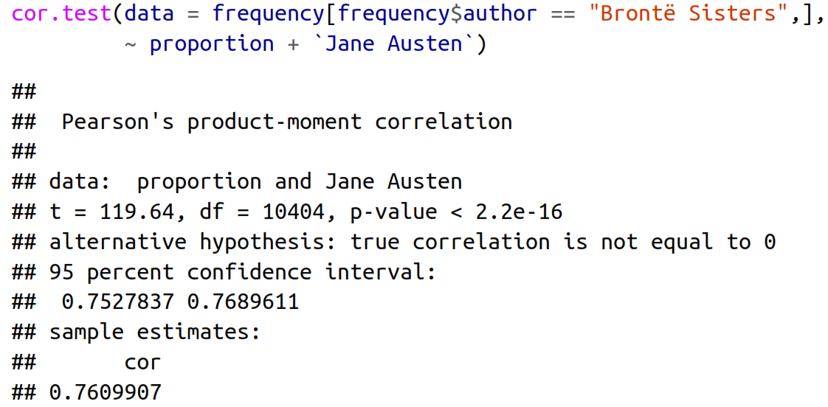

* Getting many test at once

|  |  |
| --- | --- |
| With duplicates | Without duplicates |
|  |  |

**tm::findAssocs()** calculates its correlation with every other word in a TDM or DTM at document level. Scores range from 0 to 1. A score of 1 means that two words always appear together in documents, while a score approaching 0 means the terms seldom appear in the same document.

Minimum correlation values are often relatively low because of word diversity. Don't be surprised if 0.10 demonstrates a strong pairwise term association.

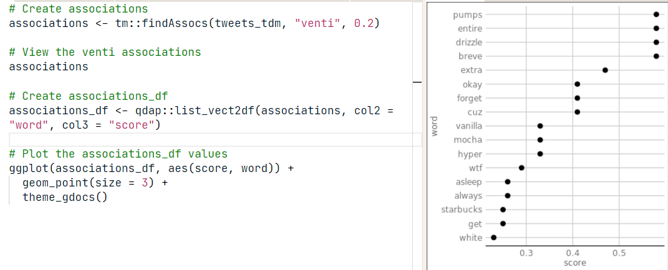

### Log odd ratio per group

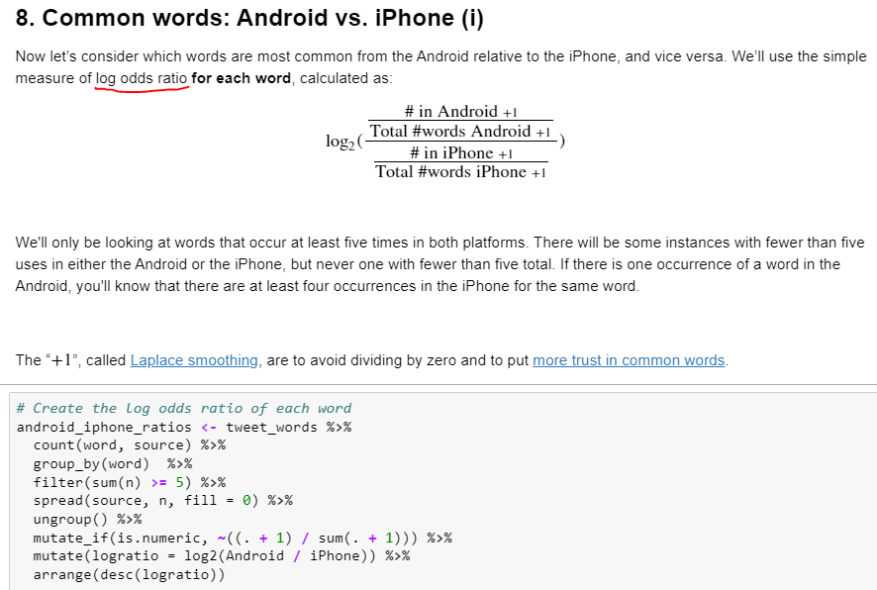

### Net sentiment per group

Per tweet, document, 80 lines

$$net semtiment =number positive words-number negative words$$

or

$$net semtiment =neg.+positive individual number word calification$$

### Proportion of negative/positive words per group

$$ratio=\frac{negative words}{Total number of words}$$

### Term frequency-Inverse document frequency (tf-idf)

* Identifies words that are especially important to a document within a collection of documents
* Finds words that are **characteristic** for one document within a collection of documents, whether that document is a novel or physics text or webpage.

$$tf_{idf}= tf*idf$$

***It might be a good idea to throw out all description fields that have very few words to avoid over loading the tf part.***

* ***Term frequency (tf):*** How frequently a word occurs in a document.
$$tf= \frac{Number of a particular world in a document}{Number of all worlds in a document}$$

* ***Inverse document frequency (idf):*** Decreases the weight for commonly used words and increases the weight for words that are not used very much in a collection of documents.

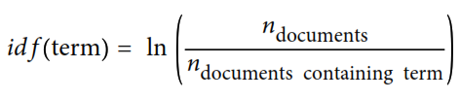

#### tidytext

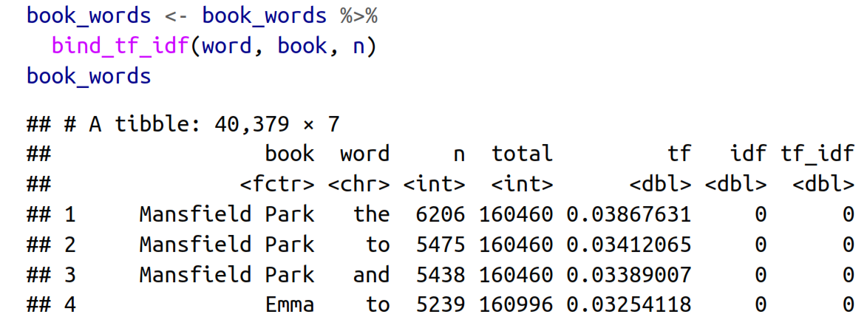

#### tm

**TFIDF,** or Term Frequency Inverse Document Frequency method. Essentially words are counted but penalized if they appear in a lot of documents. The thought being that words that are both common and across all documents have little informational value.

**TfIdf** counts terms (i.e. Tf), normalizes the value by document length and then penalizes the value the more often a word appears among the documents.

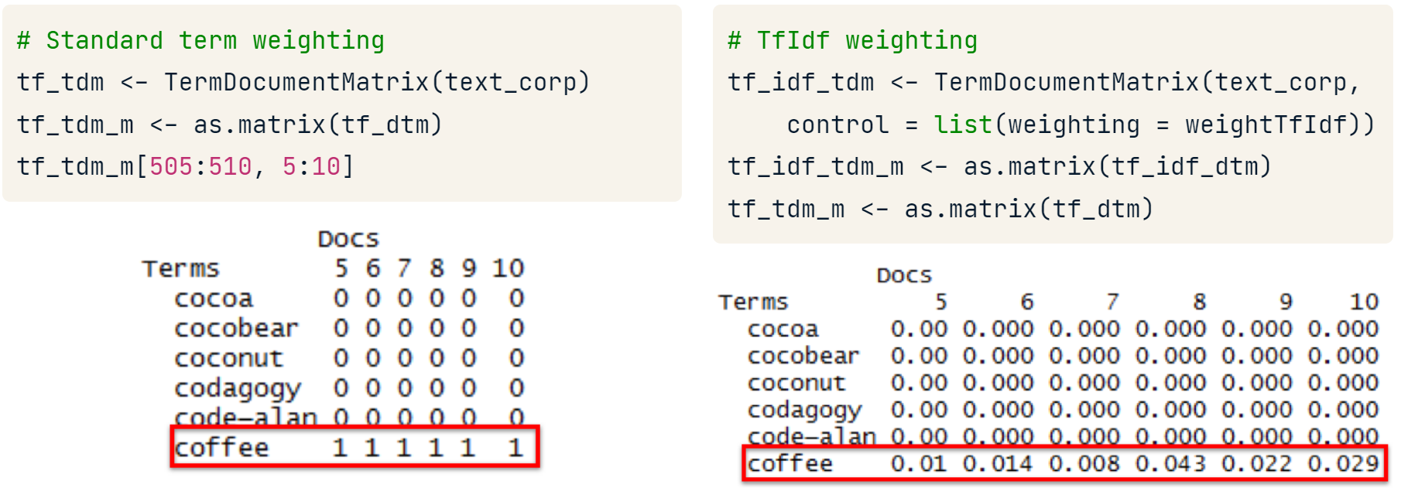

### Binomial time significant slopes

In the next example David wrote #rstas 2 times of 307 words during the January 2016.

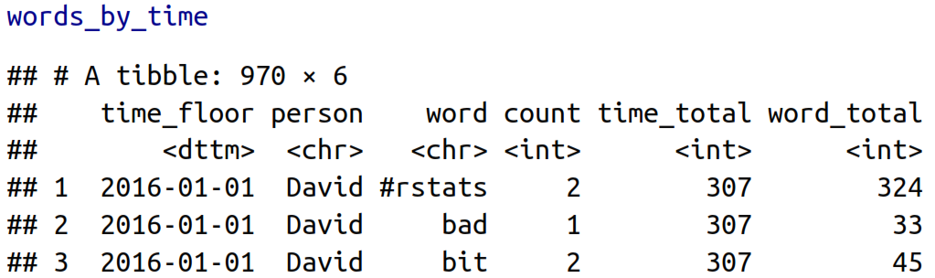

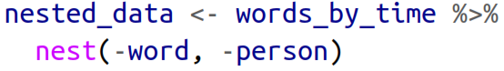

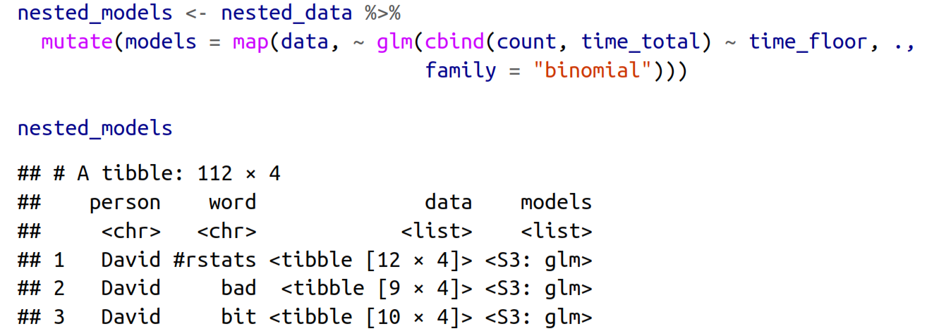

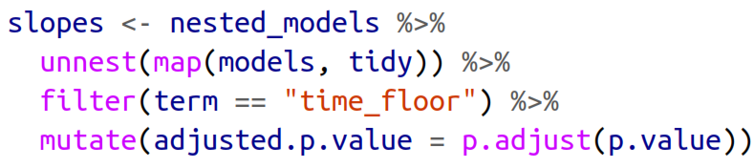

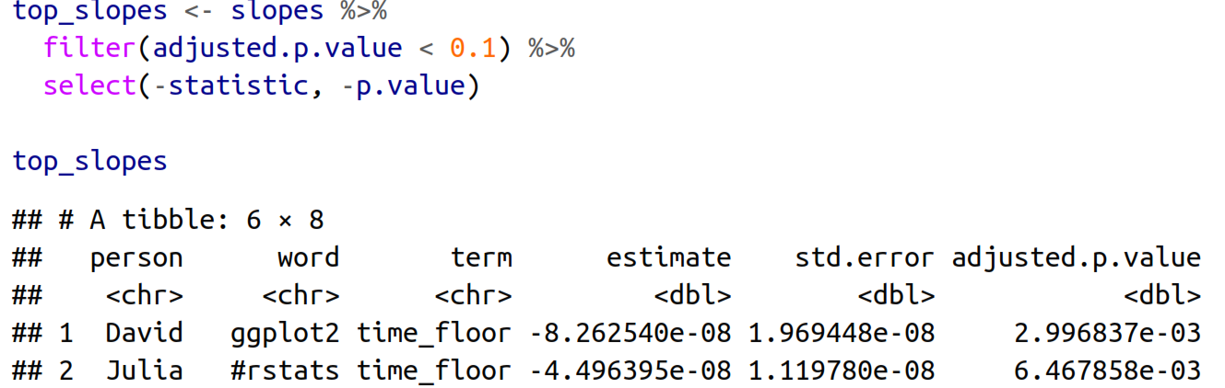

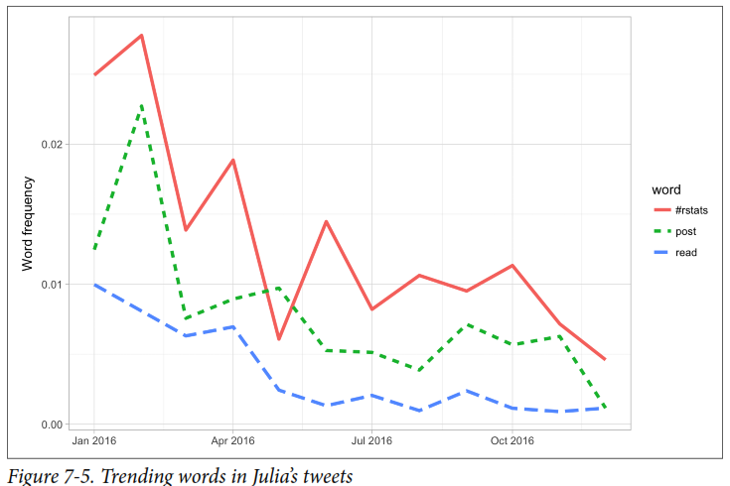

## Creating plots

### Scatter plot

#### Visualizing proportions per group

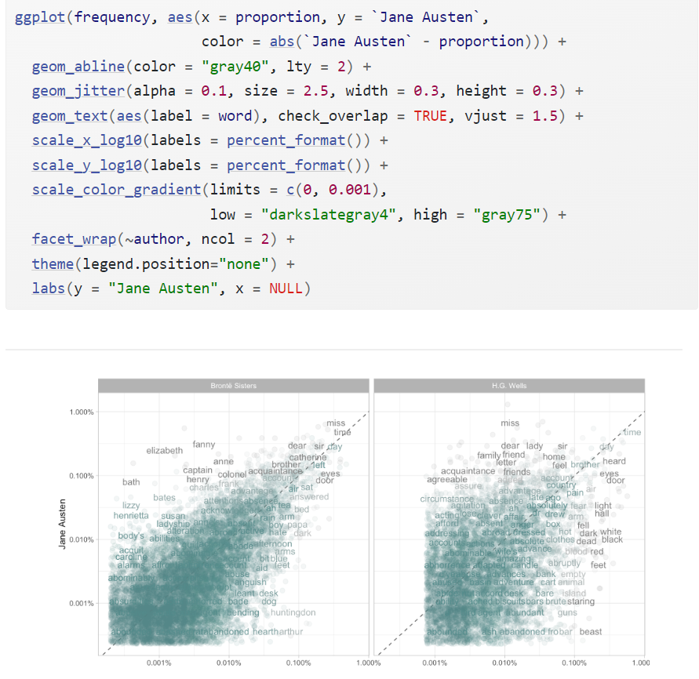



### Bar plot

#### Visualizing net sentiment across documents

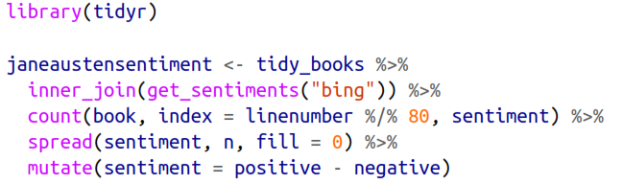

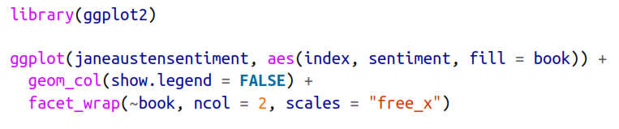

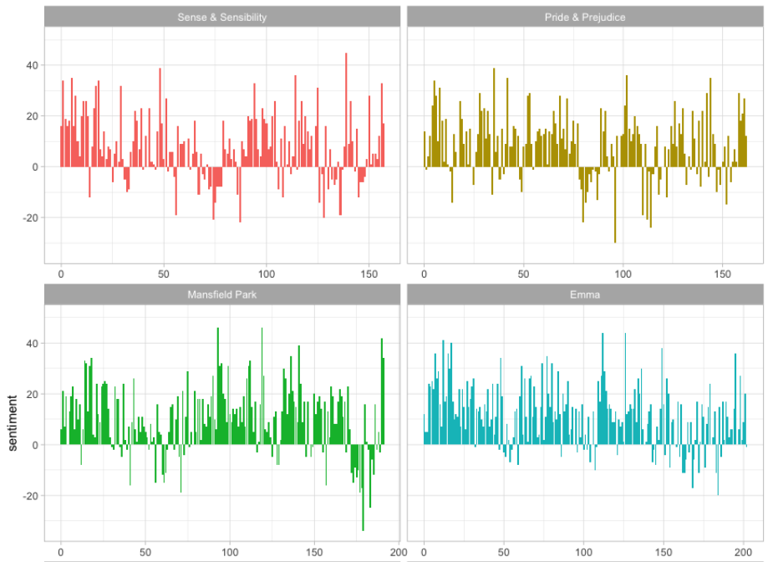

#### Showing the highest metric

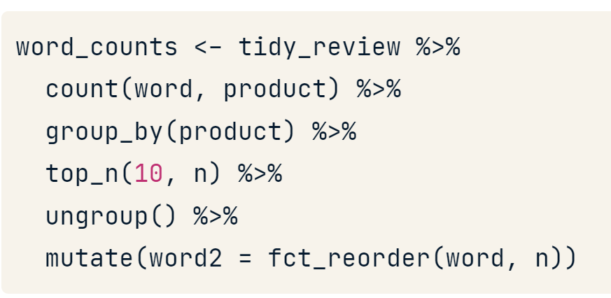

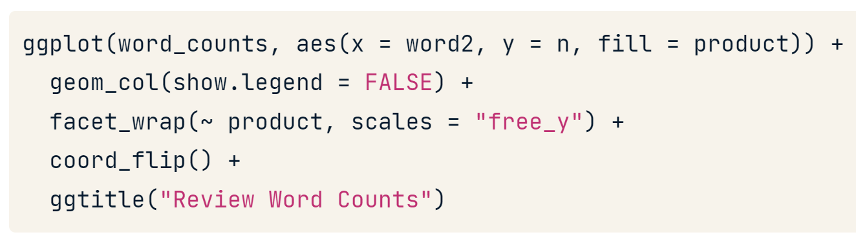

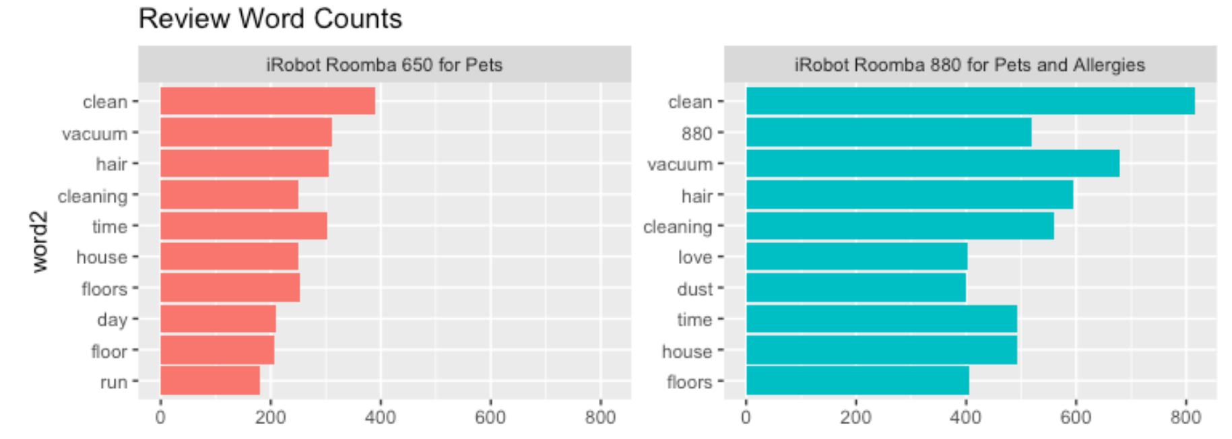

#### tm

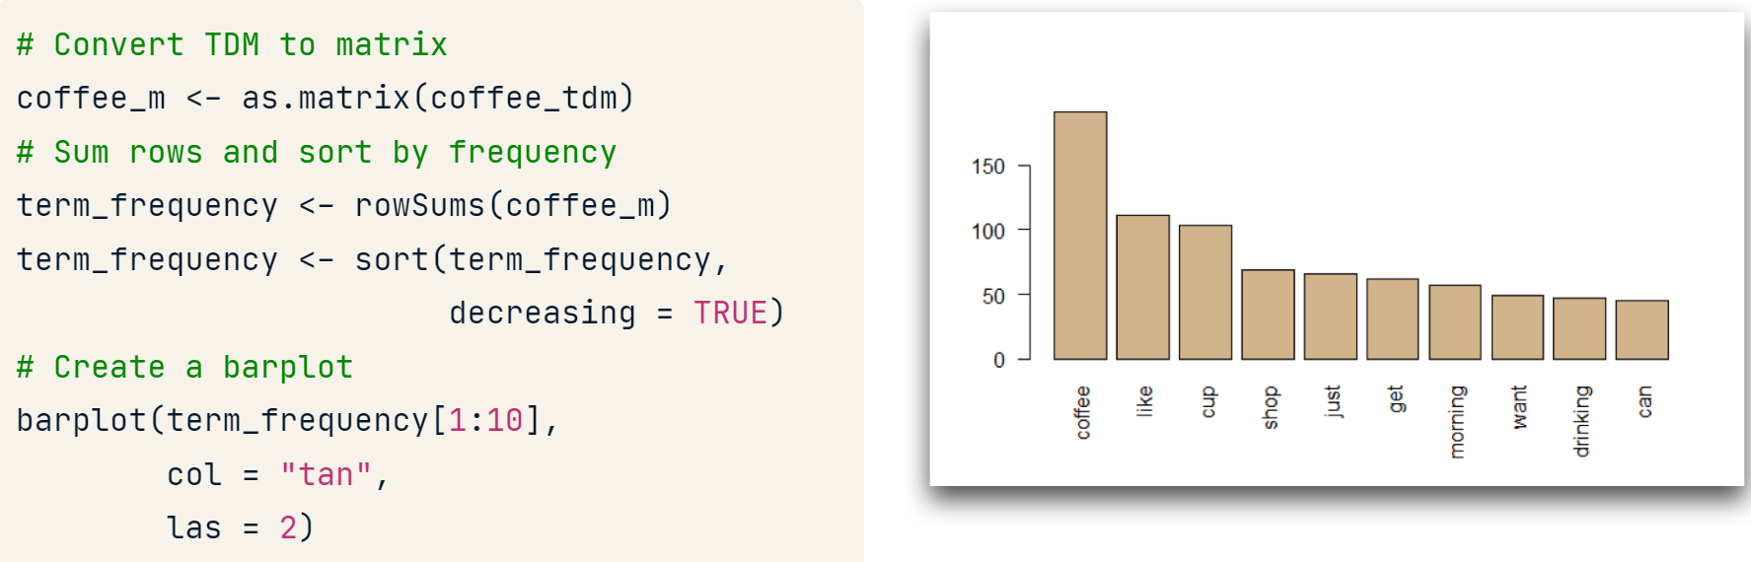

#### qdap

* Limit to the top 10 terms.
* At least three letters per term.
* Use "Top200Words" or stopwords("english") to define stop words

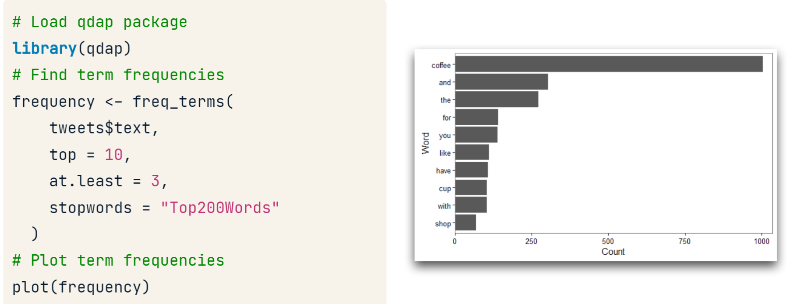

### Word network

This plot shows how words connects with other words

#### igraph and ggraph for bigrams

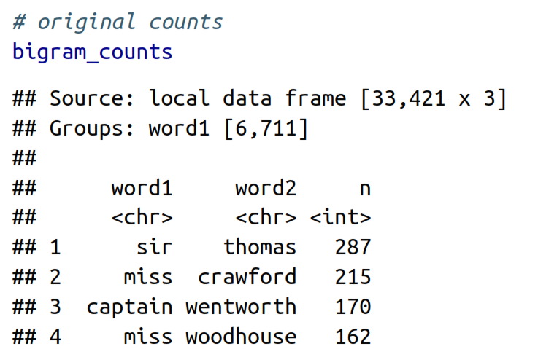

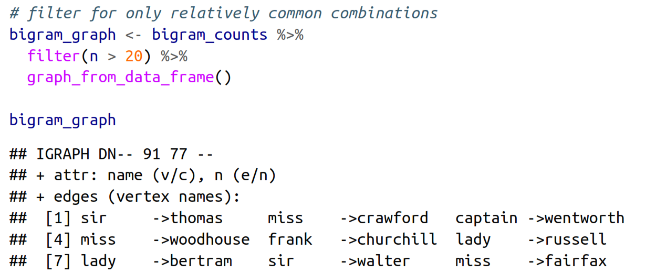

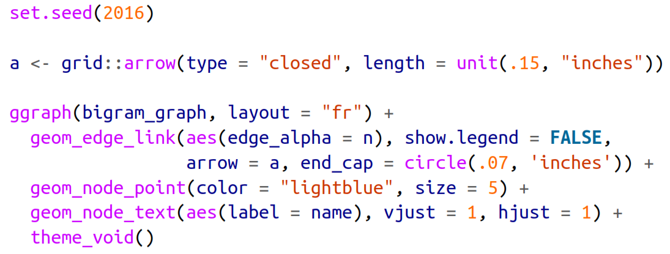

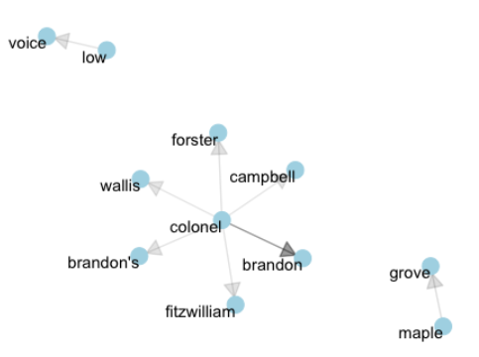

#### igraph and ggraph for correlation

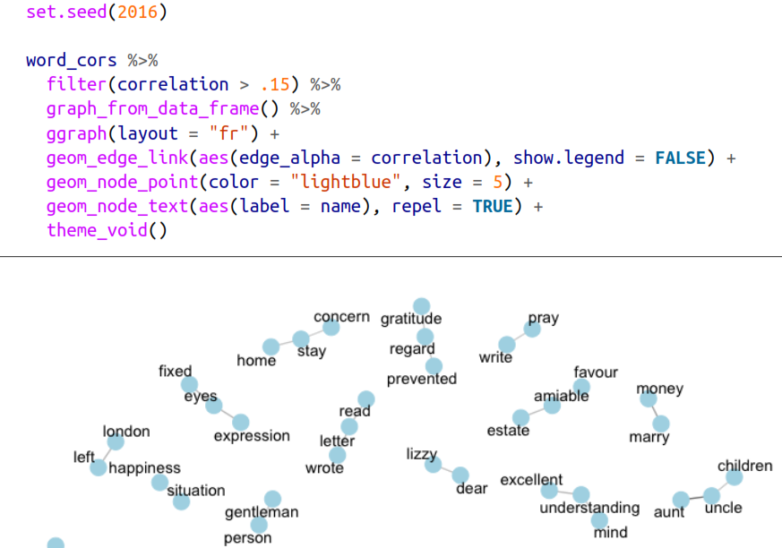

#### qdap

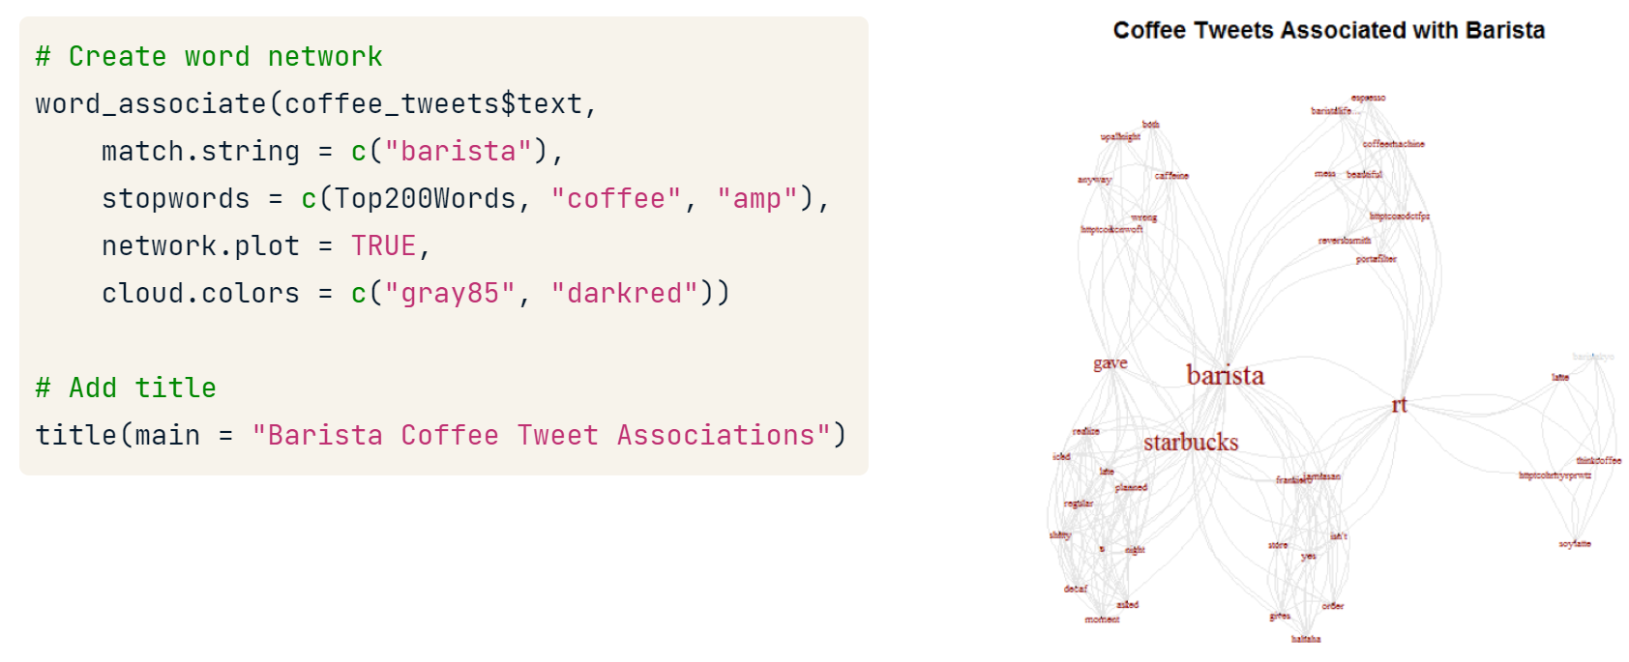

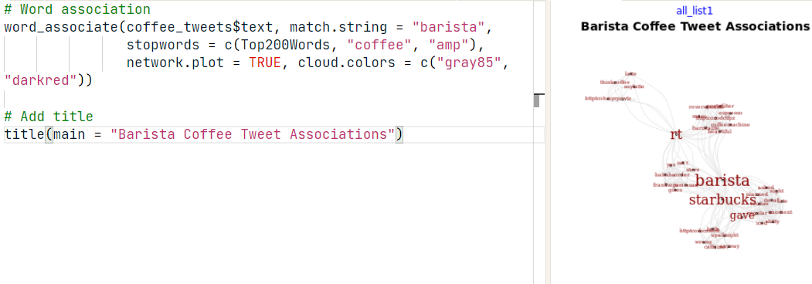

### Wordclouds

#### Showing the highest frequency

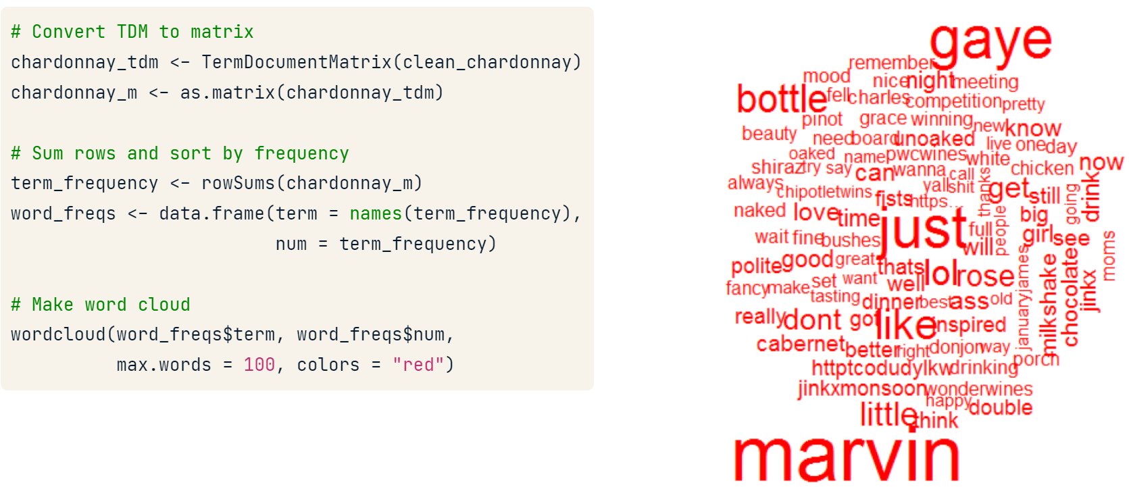

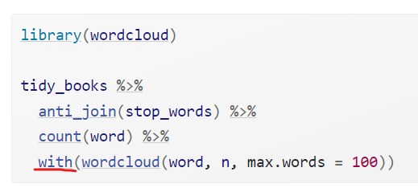

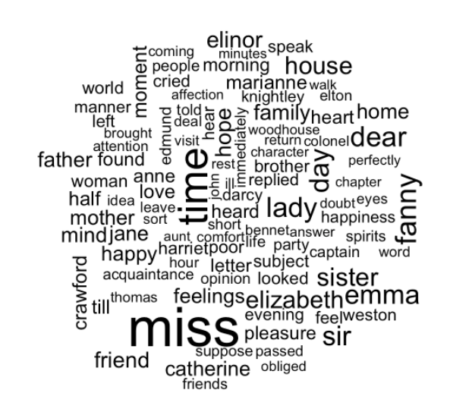

#### Showing the highest frequency per group

|  |  |
| --- | --- |
|  |  |

#### Advanced clouds

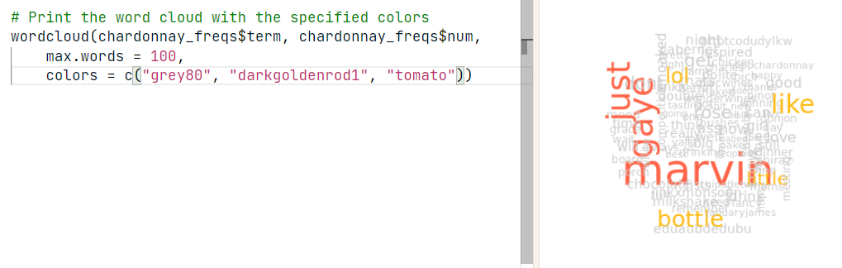

To find the intersection in a commonality-dot-cloud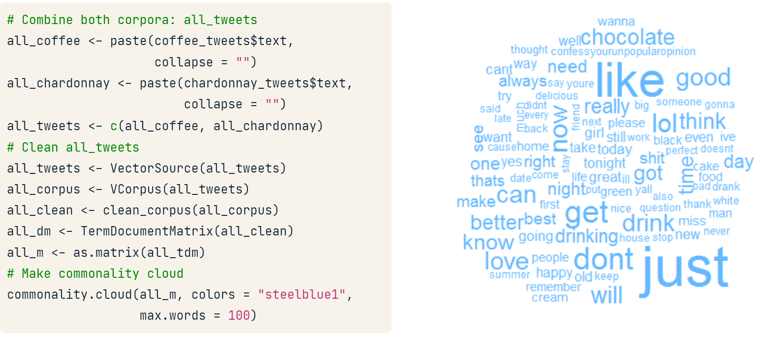

To understand the disjunction of the two documents.

* *the sizes of the words are not comparable across sentiments.*
* We can compare polarity by taking out words with polarity == 0

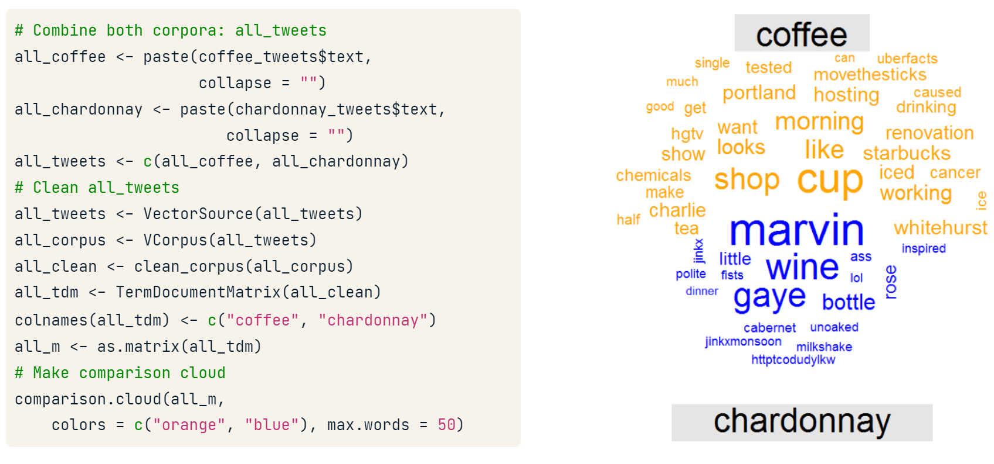

moby_tidy <- moby %>%

  inner_join(nrc, by = c("term" = "word")) %>%

  filter(!grepl("positive|negative", sentiment)) %>%

  count(sentiment, term) %>%

  spread(sentiment, n, fill = 0) %>%

  data.frame(row.names = "term")

# Plot comparison cloud

comparison.cloud(moby_tidy,

                 max.words = 50,

                 title.size = 1.5)

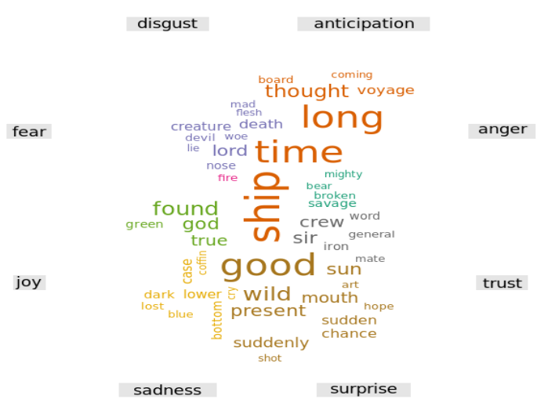

### Line plot

#### Polarity over document

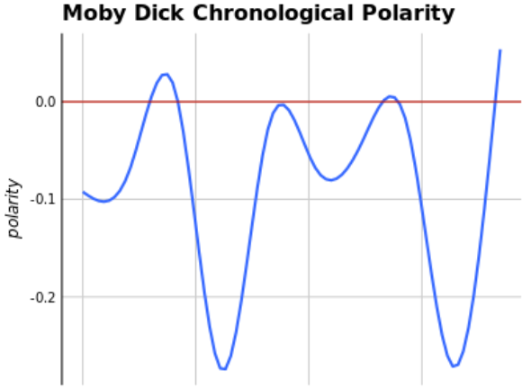

### pyramind plot

#### plotrix

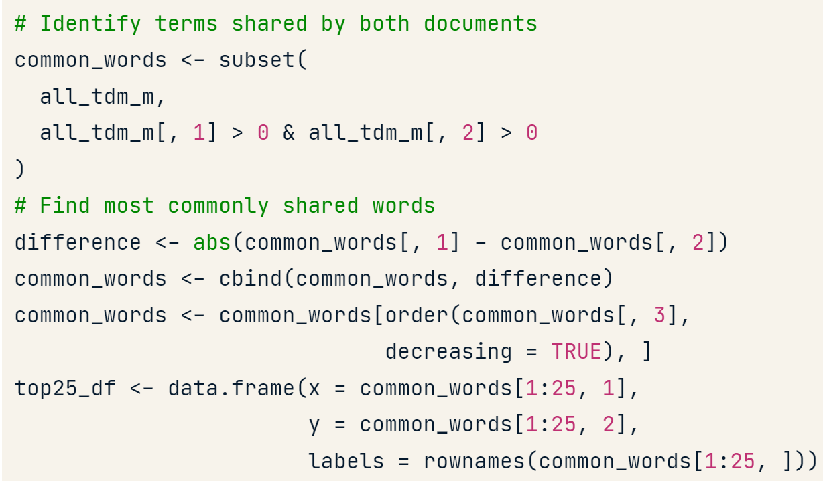

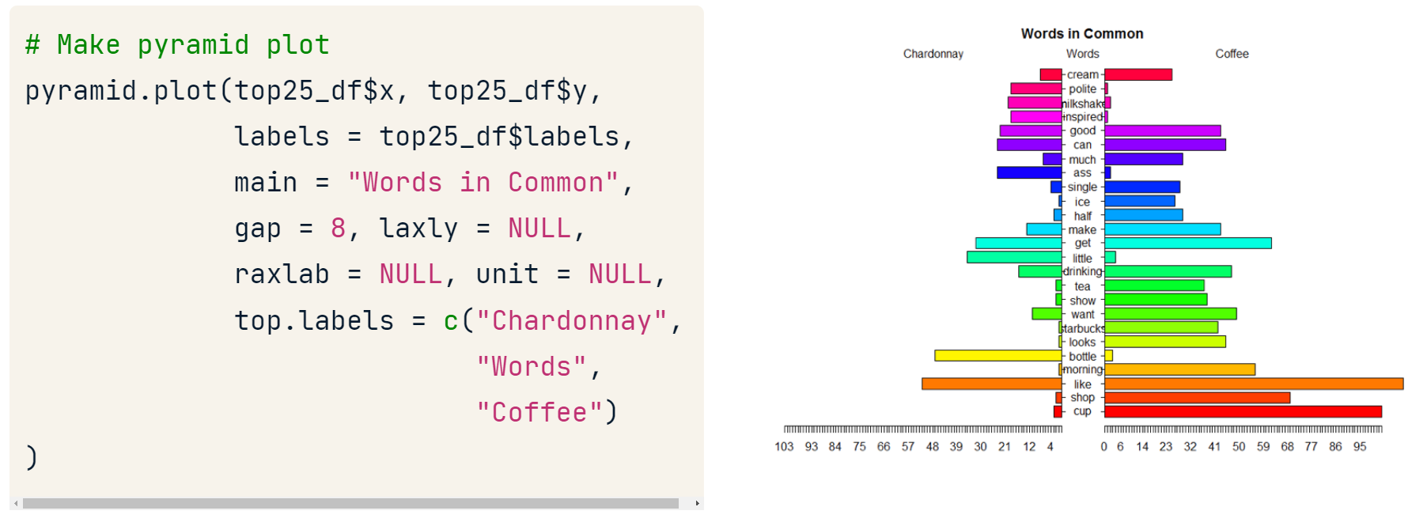

Or

pyramid.plot(word_count_data$count1,

word_count_data$count2,

word_count_data$word)

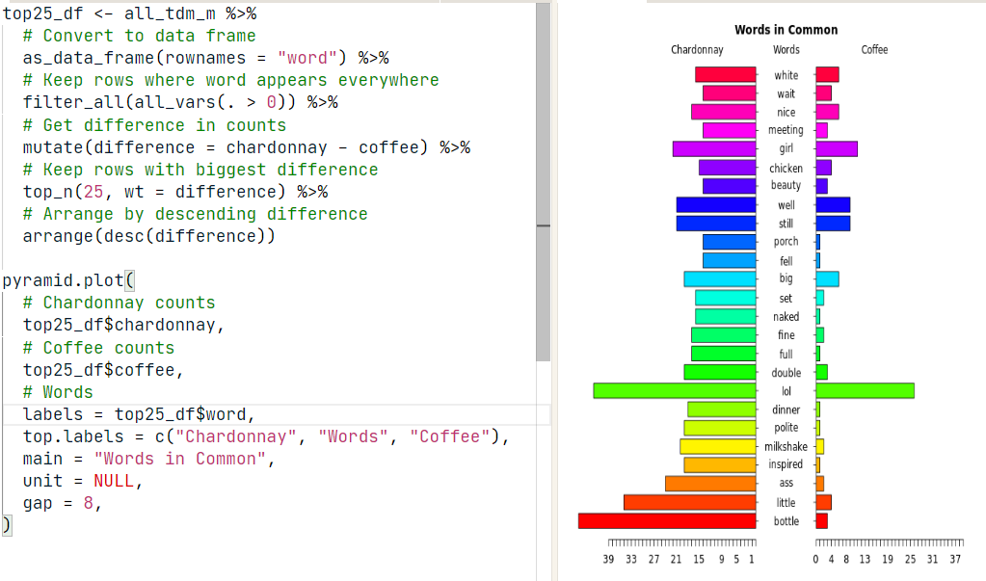

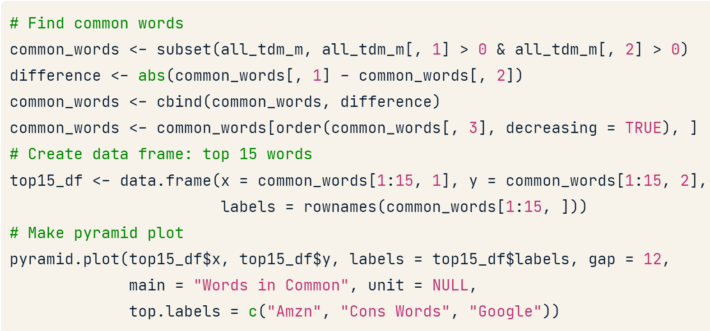

### Dendrogram (hierarchical clustering)

#### For number

dist takes every row as an unique element

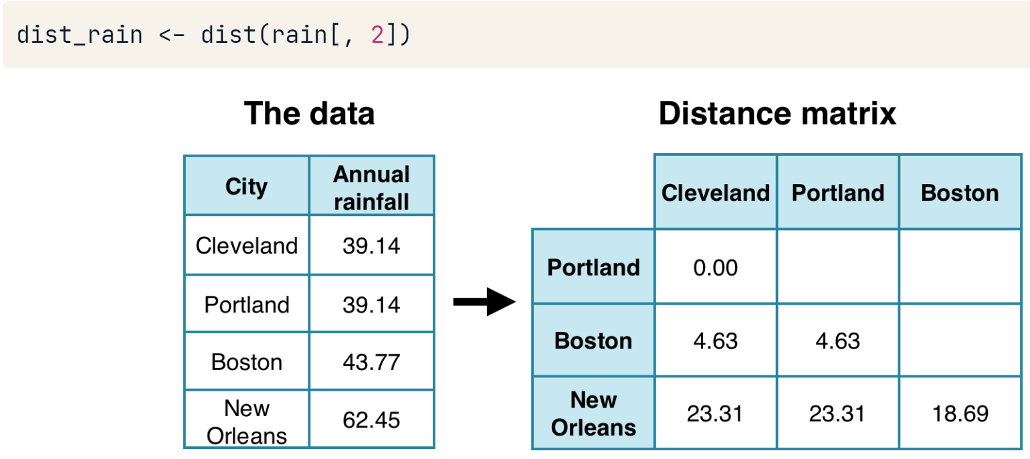

dist_rain object is passed to hclust to create a hierarchical cluster object

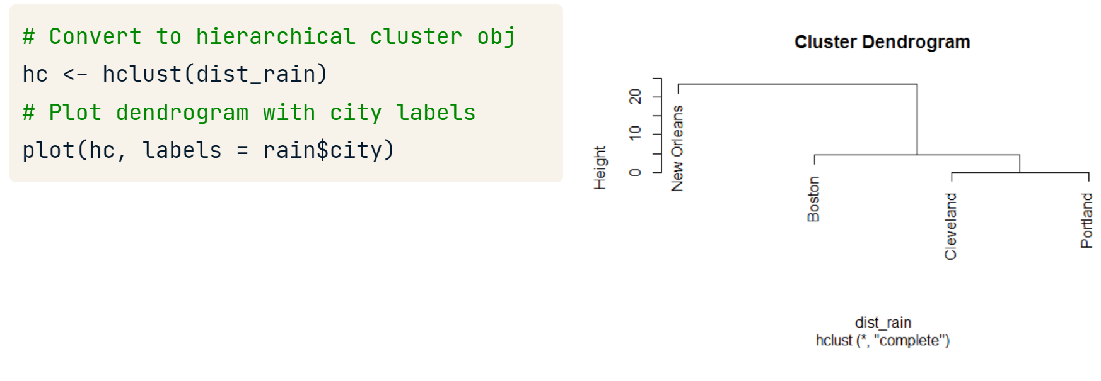

#### For words

rain is a term-document matrix

A good dendrogram is based on a TDM with 25 to 70 terms

**removeSparseTerms(),** the sparse parameter will adjust the total terms kept in the TDM. The closer sparse is to 1; the more terms are kept. This value represents a percentage cutoff of zeros for each term in the TDM.

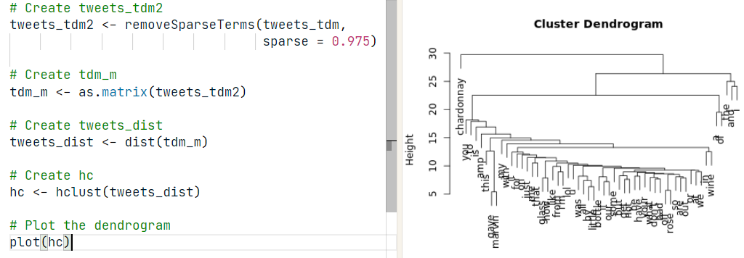

**labels()** function. It will print all terms of the dendrogram.

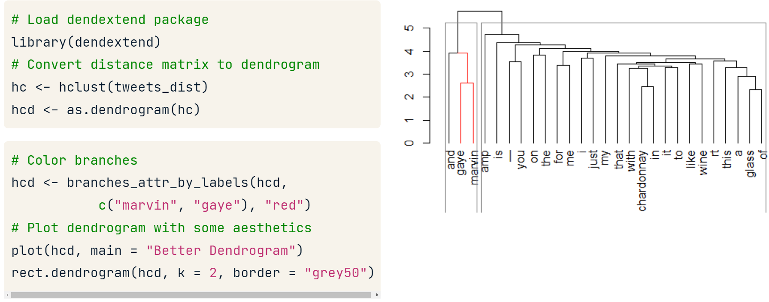

### Treemap

<https://yjunechoe.github.io/posts/2020-06-30-treemap-with-ggplot/>

## Latent Dirichlet Allocation (topicmodels)

* *Every document is a mixture of topics* as each document may contain words from several topics
* *Every topic is a mixture of words*

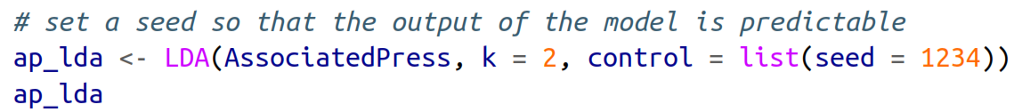

### Adding classification to corpus

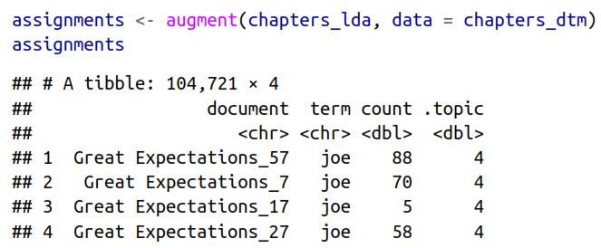

### Topic probability by word

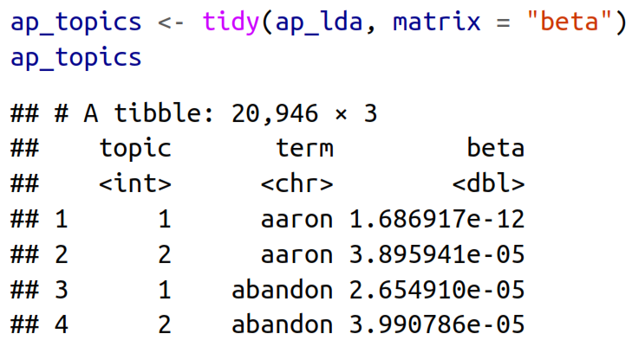

* Understanding what is the topic conent

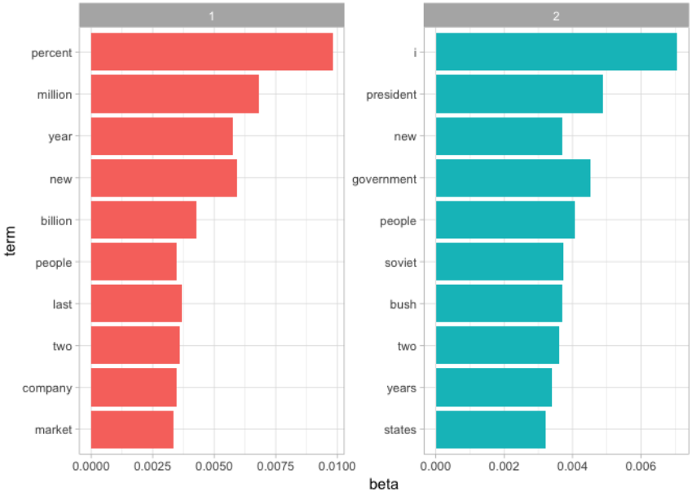

* Terms that had the greatest difference

|  |  |
| --- | --- |
|  |  |

### Topic probability by document

We select the number of K by checking this number distribution. If all documents’ probabilities are close to 0 or 1.

|  |  |
| --- | --- |
|  |  |

### Connecting topic modeling with keywords

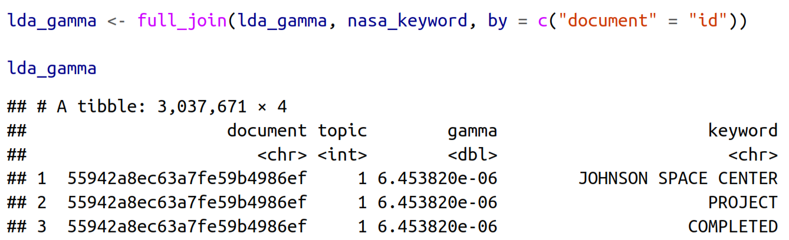

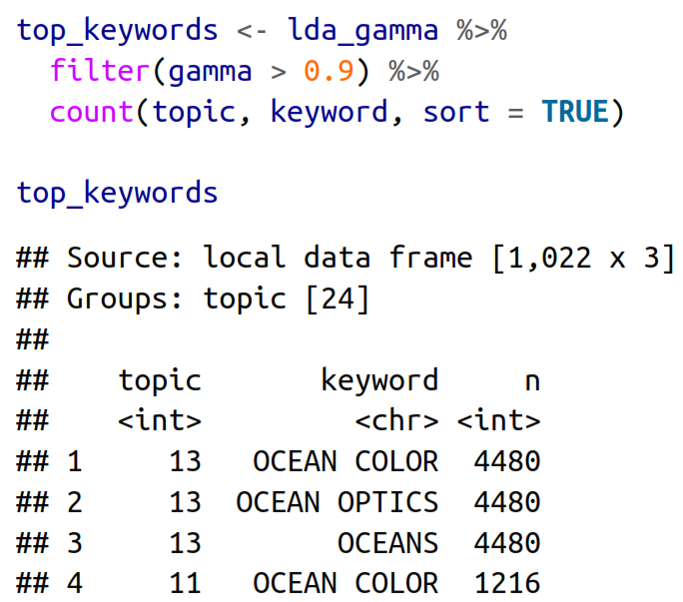

## Sentiment analysis

* To avoid positive and negative words have a 0 mean effect we should use short documents like sentences and paragraphs, but small sections of text may not have enough words in them to get a good estimate of sentiment

George Zipf created **“Zipf’s law”.** It states that given some text, the frequency of any single word is inversely proportional to its rank in the frequency table. More simply, if you counted up the word frequency in a passage, the second word would appear about half as much, fifty percent, as the first. One over the word's place on the list or one over two. Similarly, the third most frequent word could appear one third as much as the first and so on.

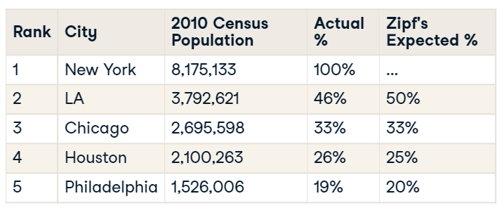

sb_words$expectations <- sb_words %$% {freq[1] / rank}

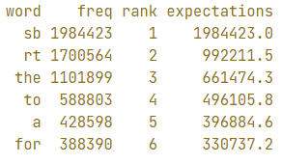

**“the principle of least effort”** from library sciences. A speaker or writer doesn't want to exert a lot of effort when communicating while the audience doesn't want to spend a lot of energy interpreting. So the word choice or lexical diversity becomes limited.

### lexicon

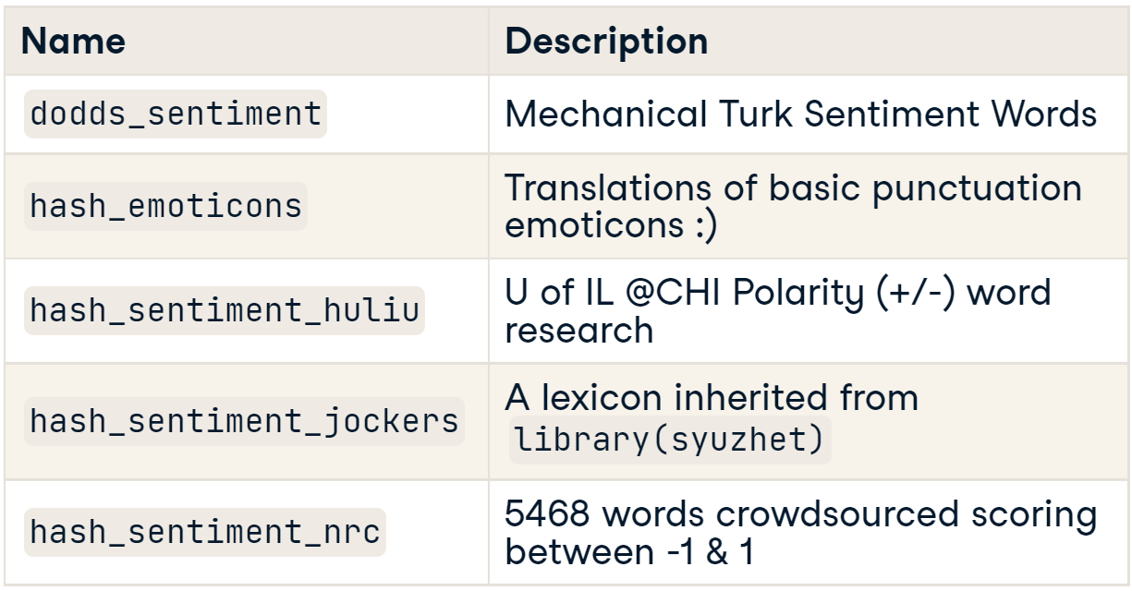

### tidytext

* We need to validate how sarcasm or negated text we have before staring the analysis.
* As we don’t know which the best lexicon to explore the data we need to compare the next with all of them

|  |  |  |
| --- | --- | --- |
|  |  | The NRC sentiment is high, the AFINN  sentiment has more variance, and the Bing et al. sentiment appears to find longer  stretches of similar text, but all three agree roughly on the overall trends in the senti‐  ment through a narrative arc. |
|  | |

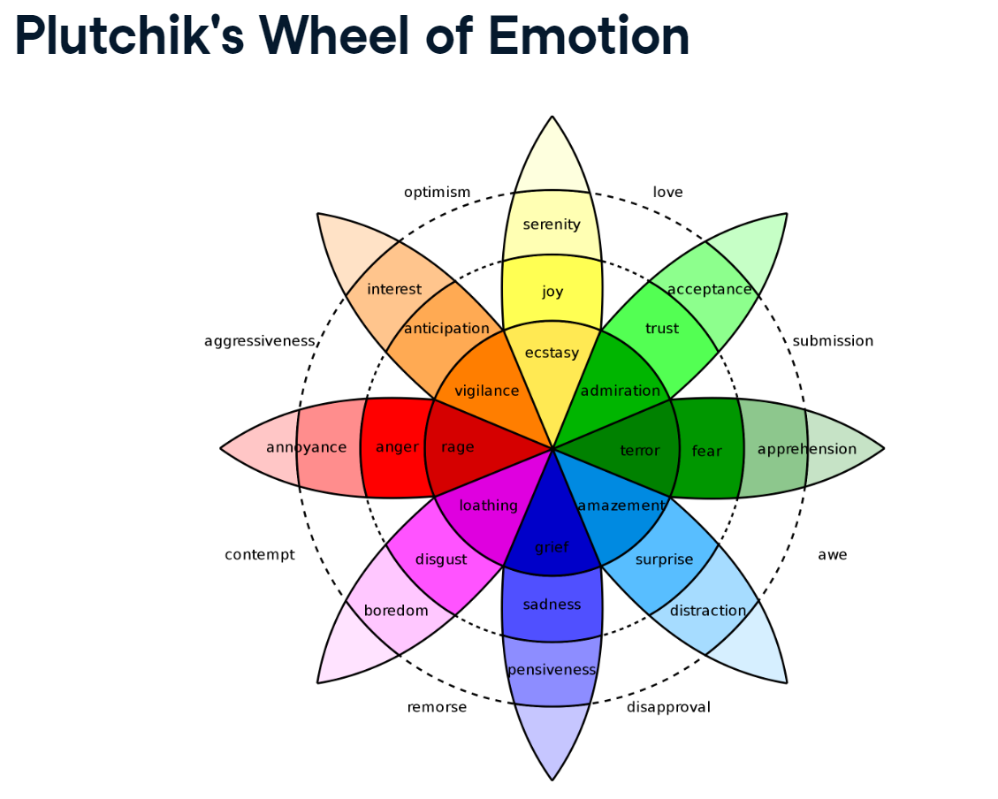

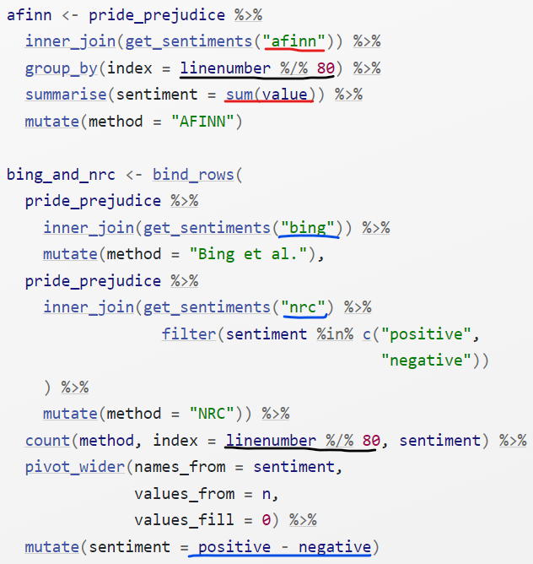

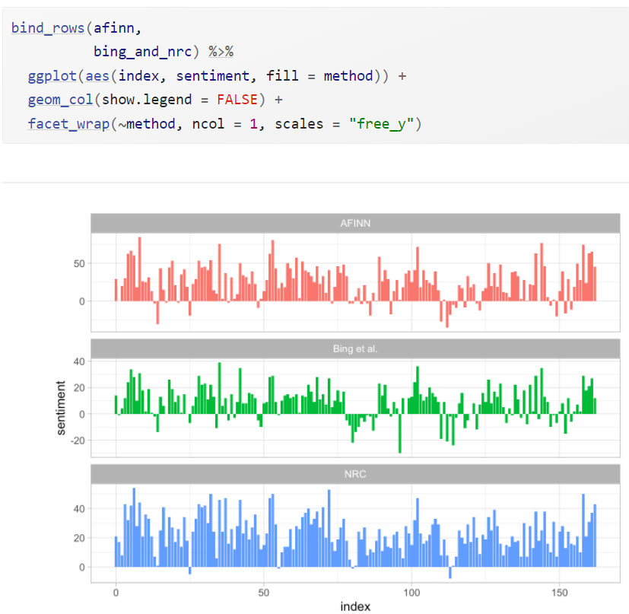

### qdap

**Getting a summary for all text**

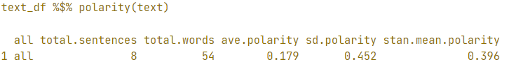

result$all is a data.frame with every polarity result.

**Getting a summary per group**

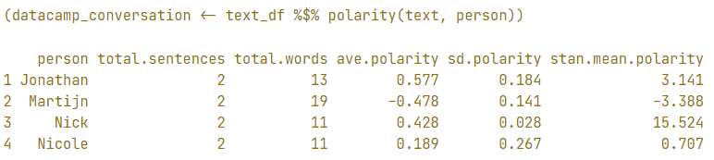

**Changing the dictionary**

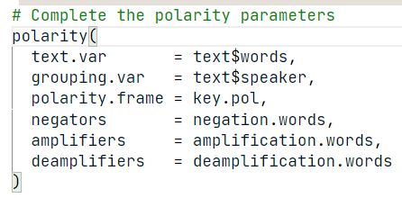

I could be necessary to **scale()** our polarity result as more negative o positive comments comes from authors that made for effort to write their comments.

**plot(datacamp_conversation)**

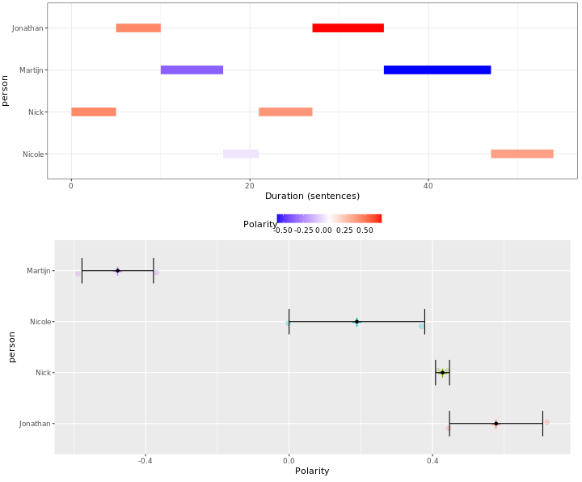

**counts()** to print the specific emotional words that were found.

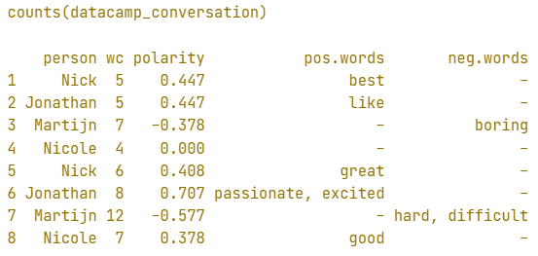

**How does it work?**

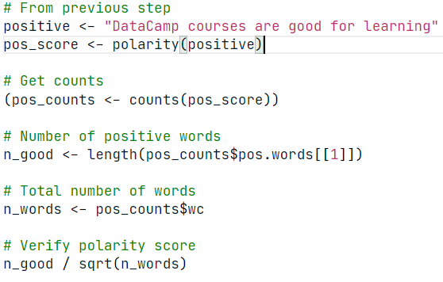

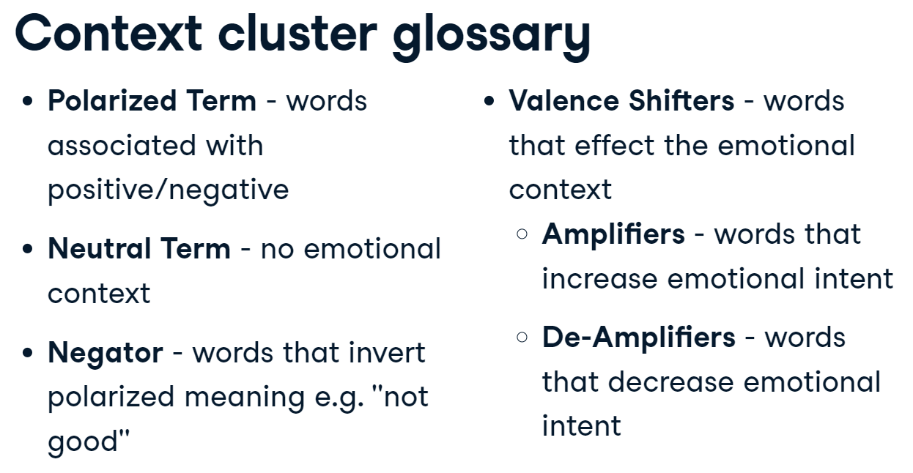

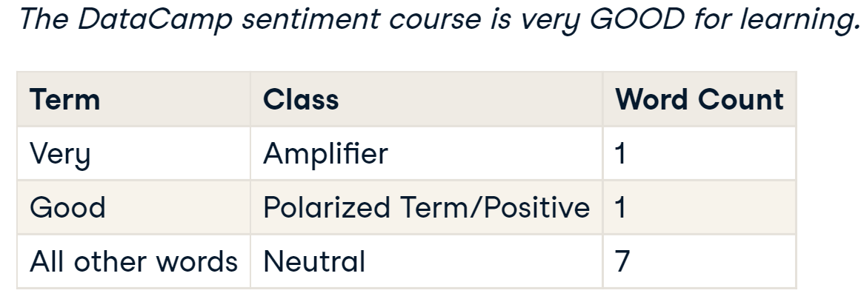

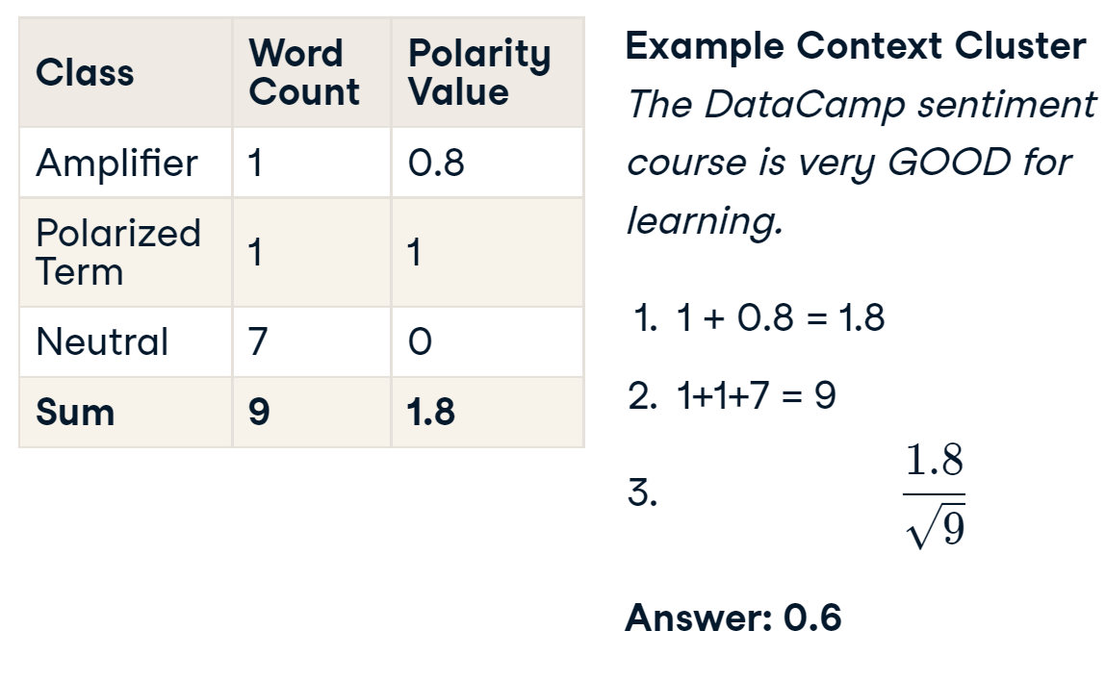

**Adding new negative/positive words**

